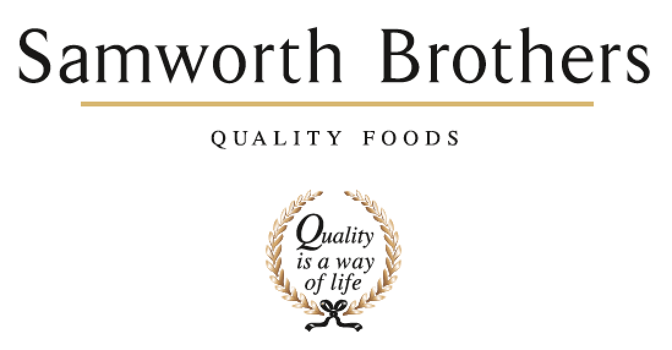

|  |  |  |  |
| --- | --- | --- | --- |
| ROLE PROFILE | | | |
| Job title | Multi Skilled Engineer | Date | June 2022 |
| Business | Walker & Son | | |
| Department | Maintenance | | |
| Location | 200 Madeline Road, LEICESTER, LE4 1EX | | |
| ROLE SUMMARY | | | |
| To support the delivery all plant asset maintenance programs. Manage all day-to-day maintenance activities both planned and reactive and assist in all Shift Engineering Team activities to ensure optimum performance levels are achieved and sustained. | | | |
| REPORTING STRUCTURE | | | |
| Reports to | Shift Engineering Team Leader | | |
| Direct & indirect reports | Production | | |
| Key internal stakeholders | Production | | |
| Key external stakeholders |  | | |
| KEY ACCOUNTABILITIES AND RESPONSIBILITIES | | | |
| To work on mechanical and electrical equipment used in production machinery and processing systems on site. Food and Drink Multi-skilled Maintenance Engineers will work with mechanical and electrical equipment plus highly automated programmable control systems.  Ensure that all maintenance activities are conducted safely and comply with food safety legislation in this highly regulated industry. Engineering activities carried out will include routine maintenance, fault finding and diagnosis, testing and commissioning. They must ensure that maintenance activities contribute to optimising food and drink production levels.  To work autonomously, taking responsibility for their own tasks and also work effectively in teams. | | | |
| QUALIFICATIONS, EXPERIENCE, TECHNICAL SKILLS / KNOWLEDGE | | | |
| **Knowledge required;**   * Food processing/manufacturing and product knowledge (to meet company requirements. * Legislation and regulations in the food and drink industry, including understanding of:   + Food Safety   + Health and Safety   + Hazard Analysis Critical Control Point (HACCP), Threat Assessment Critical Control Point (TACCP), Vulnerability Assessment Critical Control Point (VACCP)   + Basic principles of sustainability and environmental legislation   + The impact of customer requirements and demands on the food supply chain * The key principles of cleaning and hygiene processes covering both Cleaning in Place (CIP) and cleaning out of place systems * The key principles of quality management systems and processes * The key principles of Continuous Improvement (CI) Management * Materials science, including the key features of raw materials, their uses in food production and types of equipment used to process them . * Types of best practice maintenance approaches and techniques in the food and drink industry * The principles of fault finding techniques * The operation of mechanical equipment in the food and drink industry * How to produce replacement components * The function of fluid power systems * The operation of heat exchange equipment * The principles of cutting and welding in the food and drink industry * Principles of electrical systems, including their uses, safety and legislation * Services and utilities knowledge, including the importance and impact of energy management and pollution control in food production     **Additional Electrical Skills:**   * Understand the principles of electrical machines, testing electrical equipment and circuits * Understand the operation of process controllers within an engineered system * Commission and perform maintenance of instrumentation/process control systems * Perform maintenance of programmable control systems * Understand the requirements of electrical installations   **Additional Mechanical skills:**   * Monitor mechanical equipment in food and drink operations * Repair and produce replacement complex mechanical components to required standards * Produce complex welded joints in a range of positions using a range of different processes * Review welding activities | | | |
| CORE COMPETENCIES, ATTRIBUTES & BEHAVIOURS FOR SUCCESS | | | |
| **Competency** | **Descriptors** | | |
| Values People | *Demonstrates the belief that people are our most important asset and central to the success of the organisation. Everybody should be treated with dignity and respect at all times.* | | |
| Customer Focus | *Demonstrates the understanding that the satisfaction of our internal and external customers is the foundation of our success* | | |
| Collaborative Team Working | *The willingness to act as part of a team and work towards achieving shared objectives through adopting best practice in line with PQP and Federalism.* | | |
| Flexibility & Adaptability | *The ability to change and adapt own behaviour or work procedures when there is a change in the work environment, for example as a result of changing customer needs.* | | |
| Initiative & taking ownership | *Steps up to take on personal responsibility and accountability for tasks and actions in line with PQP and Federalism.* | | |
| Drive for Excellence | *Knows the most effective and efficient processes for getting things done, with a focus on continuous improvement.* | | |
| Resource Management | *Effectively manages resources and cost drivers to achieve sustainable productivity and profitability.* | | |
| Technical Expertise | *Has the skills, knowledge and experience required to excel in own area of specialism and the willingness to further grow and develop.* | | |
| Self-Management | *Uses a combination of feedback and reflection to gain insight into personal strengths and weaknesses, so that own time, priorities and resources can be managed to achieve goals.* | | |