` 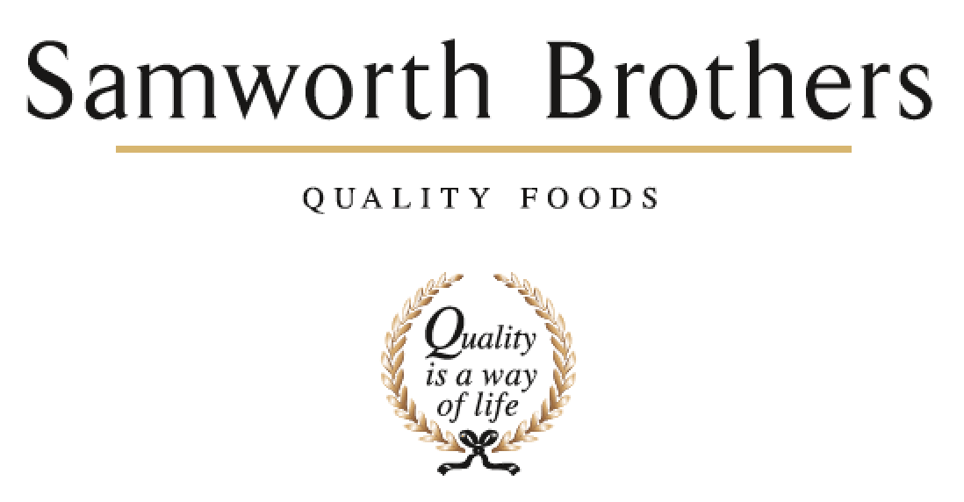

|  |  |  |  |
| --- | --- | --- | --- |
| ROLE PROFILE | | | |
| Job title | Site Director | Date | September 2025 |
| Business | Meals | | |
| Department | Senior Leadership Team | | |
| Location | Saladworks, Leicester | | |
| ROLE SUMMARY | | | |
| We are looking for a suitably experienced and qualified Operational Leader for the role of Site Director, Saladworks. The role will be part of the Meals Category Leadership Team reporting into the Category Managing Director, Meals. This role is responsible for the day to day running of the manufacturing site and facilities. This includes having direct ownership of the operational functions and the running of a cross functional senior team to ensure delivery of the strategy and annual budget. | | | |
| REPORTING STRUCTURE | | | |
| Reports to | Category Managing Director | | |
| Deputy | Site Operations Manager | | |
| Direct & indirect reports | Engineering Manager, People Lead, Technical Lead, Supply Chain Manager, H&S Manager | | |
| Key internal stakeholders | Category Commercial Director, Category Finance Director, Group Manufacturing Excellence Lead, Health & Safety Director, Group Technical Controller, Group Reward and People Relations Director | | |
| Key external stakeholders | Customers, HSE, Other enforcement agencies | | |
| KEY ACCOUNTABILITIES AND RESPONSIBILITIES | | | |
| * To be an active leader within the Meals Team, contributing to the strategy, direction, performance, and governance of the business - specifically to ensure that we meet profitability, growth and working capital targets. * As a leader you will be flexible in style, decisive and collaborative, creating rhythm and routine that allows you to effectively delegate whilst keeping your finger on the pulse of business performance * To be a role model for our Business Purpose, Values and Culture Framework. Working with the Site Leadership Team and other key stakeholders to further develop and sustain the culture of the business. * Develop and champion ‘Customer at the Heart’ within the site and support across the category, ensuring a total focus on delighting our customers and driving a pro-active growth agenda. * Promote cross functional alignment and collaboration for the overall benefit of the business * Develop and implement a site operational strategy to meet the goals of the business and to underpin the business level strategy. Continually review and adjust the strategy in line with internal and external changes. Undertake competitive benchmarking assessment to ensure site targets and capabilities are continually challenged. * To lead and manage all site operational activities to deliver business objectives, goals and targets. Particular focus is required on business planning and strategy deployment whilst employing the principles and philosophies of operations excellence / lean manufacturing to ensure that the strategic goals are achieved and sustained. * Lead the site operations team to ensure they are engaged and high performing.  Build trust through the skilled application of people management processes and open two-way communication * Embrace people development – efficiency, skill sets and retention. Grow and develop talent – building connection and commitment to the business through * Identifying those who have the interest and ability to progress into bigger or different roles * Develop skills and careers leading to a culture of growth, high performance and continuous improvement * Managing on-going performance of direct reports with regular reviews of performance * Establish site performance targets in People, Quality, Cost and Delivery that deliver against the site strategy.  Specifically, evaluate and define the required operational capabilities to meet the needs of the business in terms of: * Product Quality (High and Low care operations) * Service (Order Lead Times, Flexibility, MOQs) * Cost (Materials, Labour, Overhead) * Manufacturing capacity and capability * Operational excellence / lean maturity * Identify gaps from current state to expected requirement and prepare plans to bridge gaps * Analyse & report performance metrics (P,Q,C,D). Through analysis of business performance data, identify performance gaps, trends and improvement opportunities. Communicate internally using visual management standards and effective deployment to line level. * Organisation Development - lead the site journey towards manufacturing excellence/lean by demonstrating the behavioural requirements that are required including * Communicate the vision * Take ownership of site lean maturity * Set the pace * Mobilise and collaborate with all functions to support the operational agenda and value creation * Confirm standardised processes (layered confirmation) * Demand factual data * Insist that problems are made visible * Show support by relentlessly removing obstacles * Lead disciplined (root-cause) problem solving methodology and practices on site * Define Manufacturing Capital Budget and projects. Understand and develop the requirements for capital funding: * To meet the need for development of new products as defined through innovation & NPD based on consumer insight / market need. Explore complementary technologies that could provide significant opportunities to transform current processes. * To meet the need for production efficiency improvement / conversion cost reduction/ Capacity expansion * To meet the need for equipment and asset replacement to maintain a high quality and effective asset base in line with Group standards * Be commercially aware and have a consistent focus on the customer and their requirements * To champion Health, Safety, Environmental standards & general well-being for all of employees. Creating a safe environment which is comfortable for the bakery team to work in, ensuring that safety regulations and standards are followed and that their people are engaged in supporting a safe working environment for the benefit of all colleagues * Develop and execute the sites responsible business agenda, taking account of Group objectives, specific site targets and community engagement requirements * Support management of site communications & engagement - actively manage site communications with all internal and external stakeholders. This will involve site involvement and engagement in the local community and statutory bodies. Passionately promote the site with external and internal stakeholders, including customers. Play an active part in Internal Relations including reward and pay negotiations. * Risk & Contingency planning & execution - develop and update a Business Continuity Plan (BCP) for the site considering all operational and strategic risks that need to be managed. * Develop contingency plans for all risks with a high score * Conduct regular scenario tests to ensure BCP is relevant * Execute Business Continuity plan when required | | | |
| QUALIFICATIONS, EXPERIENCE, TECHNICAL SKILLS / KNOWLEDGE | | | |
| * Experience of holding a senior level role within an operational biased function. * Experience of successfully delivering significant change programmes within a group led business, implementing cultural and system change * To have operated with a leadership role and to demonstrate strong collaboration across a multi-functional team * Fluent understanding of financials * Excellent understanding of culture, and how to engage an entire business. * Ideally degree educated or equivalent * Proven experience of implementing and leading on Lean Manufacturing Principles * Energy & resilience - most problems stop at their door * Credible & visible leader on site and within the broader business * Ability to engage across a large number of employees * Calm under pressure - firefighting whilst retaining focus * Able to manage self-care & wellbeing - often operate on their own * Able to act on and trust own initiative - does not need to seek approval * Patience, calmness & discipline * Lead from the front - having the character to create an environment of positivity and energy * An authentic leader and with a genuine passion for their business and its people * Ability and tenacity to make things happen * High level of listening skills - support influencing across teams and key stakeholders | | | |
| CORE COMPETENCIES, ATTRIBUTES & BEHAVIOURS FOR SUCCESS | | | |
| **Competency** | **Descriptors** | | |
| Values People | *Demonstrates the belief that people are our most important asset and central to the success of the organisation. Everybody should be treated with dignity and respect at all times.* | | |
| Customer Focus | *Demonstrates the understanding that the satisfaction of our internal and external customers is the foundation of our success* | | |
| Collaborative Team Working | *The willingness to act as part of a team and work towards achieving shared objectives through adopting best practice in line with our Group purpose and Values.* | | |
| Flexibility & Adaptability | *The ability to change and adapt own behaviour or work procedures when there is a change in the work environment, for example as a result of changing customer needs.* | | |
| Initiative & taking ownership | *Steps up to take on personal responsibility and accountability for tasks and actions in line with our Group purpose and Values..* | | |
| People Management | *The ability to understand people and their motivations, build good relationships with them and help them unlock their potential.* | | |
| Decision making and judgement | *In line with our Group Purpose and Values, makes timely and informed decisions that fully consider the facts, goals, constraints and risks that keep the organisation moving forward.* | | |
| Commercial awareness | *Demonstrates an understanding of the impact decisions and actions have on the organisation in line with our Group Purpose and Values.* | | |
| Developing partnerships | *The ability to establish formal and informal relationships inside and outside the organisation, and to anticipate and balance the needs of those whose cooperation is needed for the long-term success of the business.* | | |
| Engaging others through change | *The ability to communicate a compelling vision throughout the organisation, generating genuine motivation and commitment and to act as a sponsor of change.* | | |
| Focussing on the future | *Demonstrates enthusiasm about our future by identifying strategic issues, opportunities to drive sustainable, profitable growth, and managing risk.* | | |