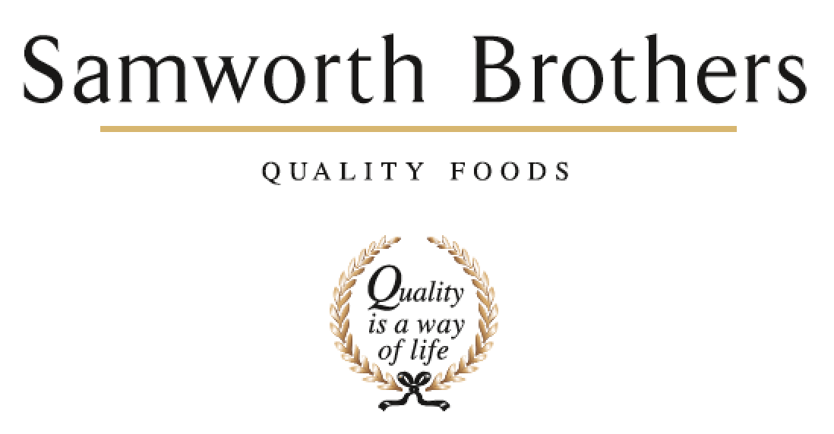

ROLE PROFILE
Job title | Technical Manager | Date | March 2024
Business | As applicable
Department | Technical
Location | As applicable
ROLE SUMMARY
To ensure that all aspects of food safety, quality and legality for the products manufactured are complied with ensuring that the technical integrity of the site is maintained.

REPORTING STRUCTURE
Reports to | Head of Technical - Category
Direct & indirect reports | QA manager x 2, Technical Compliance Manager, Process Manager
Key internal stakeholders | Managing Director, Site Director, Operations team, Group Technical Function, Commercial function
Key external stakeholders | Customers (Multiple Retailers and B2B)

KEY ACCOUNTABILITIES AND RESPONSIBILITIES
- Deliver group, customer and category strategy within the site.
- Ensure the site meets all legislative and customer standards, including group policies.
- Manage comms and relationship (maintain) with customers and external contacts.
- Adopt and embed Samworth way best practice.
- Provide technical expertise to site management team.
- Implement appropriate KPI reporting and management review to drive continuous improvement.
- Develop and grow on site technical team (recruitment, training and succession planning).
- Supporting Samworth gate process and delivery of critical path – including specs/artwork/raw materials.
- Ownership of site technical budget – support and delivery of site Profit Improvement Plans (PIPs).
- Setting of hygiene standard with monitors and corrective actions.
- Define and monitor customer non-negotiable analytical standards – Initiate root cause investigation for non-compliance.
- Deliver the internal audit programme for site within prescribed timescales.
- Active engagement and implementation of change management across the site.
- Support site health and safety objectives.
- To oversee the supplier approval system for raw materials and packaging suppliers potentially entering the business and to ensure all are risk assessed and approved prior to purchasing approval.
- Adherence to Samworth quality framework.
- Delivery and implementation of effective risk management process and root cause investigation to drive continuous improvement.

QUALIFICATIONS, EXPERIENCE, TECHNICAL SKILLS / KNOWLEDGE
- Significant experience in quality/technical management roles in fast paced, chilled, food manufacturing environments.
- Technical knowledge and expertise within chilled food.
- A good technical knowledge of supermarkets food safety requirements plus a working knowledge of their IT systems.
- Experience of Tesco TFS and BRC.
- Knowledge of M&S and JS standards
- HACCP Level 4
- Food Safety Level 4
- Proven skills in developing and leading teams
- Proven skills in coaching and mentoring
- Excellent verbal and written communication skills
- Strong influencing skills
- The ability to deliver a compelling vision for technical quality at all levels both internally and externally
- Excellent knowledge of MS Office – Word / Excel / PowerPoint.
- Strong communication and interpersonal skills including both written and verbal communication
- Flexible approach
CORE COMPETENCIES, ATTRIBUTES & BEHAVIOURS FOR SUCCESS
Competency | Descriptors
Values People | Demonstrates the belief that people are our most important asset and central to the success of the organisation. Everybody should be treated with dignity and respect at all times.
Customer Focus | Demonstrates the understanding that the satisfaction of our internal and external customers is the foundation of our success
Collaborative Team Working | The willingness to act as part of a team and work towards achieving shared objectives through adopting best practice in line with PQP and Federalism.
Flexibility & Adaptability | The ability to change and adapt own behaviour or work procedures when there is a change in the work environment, for example as a result of changing customer needs.
Initiative & taking ownership | Steps up to take on personal responsibility and accountability for tasks and actions in line with PQP and Federalism.
People Management | The ability to understand people and their motivations, build good relationships with them and help them unlock their potential.
Empowering others | Creates an environment where people feel required and enabled to take ownership and responsibility.
Coaching for performance | The ability to help others achieve more through two-way feedback, clear direction and enabling.
Analysis & Planning | The ability to take a range of information, think things through logically and prioritise work to meet commitments aligned with organisational goals.
Drive for Excellence | Knows the most effective and efficient processes for getting things done, with a focus on continuous improvement.

