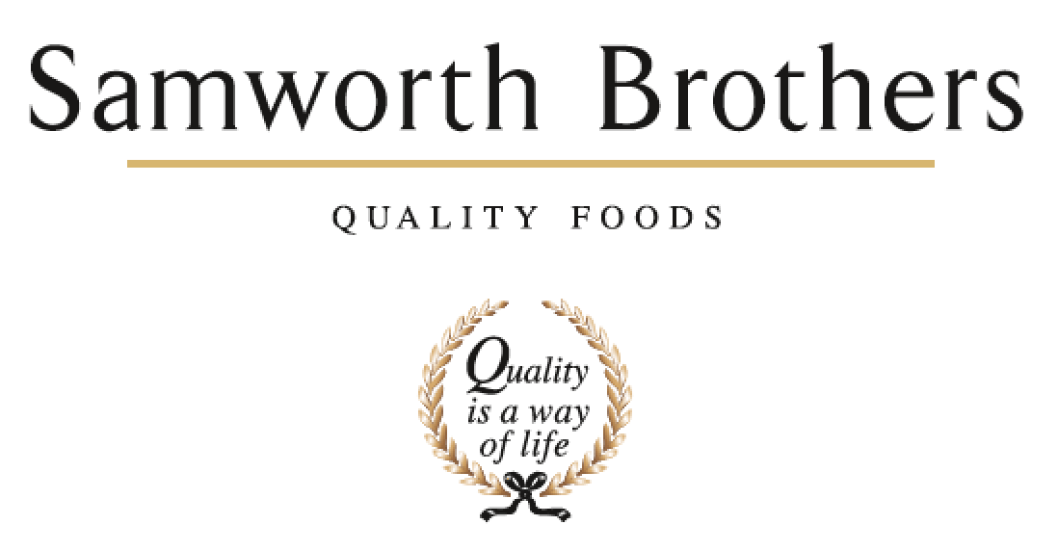

ROLE PROFILE
Job title | Hygiene Operative | Date | August 2023
Department | Hygiene
Location | Trafford Park
ROLE SUMMARY
Summarise in one or two sentences the highlights of the job in terms of its purpose and overall responsibility.
To ensure the hygiene standards are maintained and areas cleaned according to cleaning schedules with all relevant paperwork completed for the jobs.
REPORTING STRUCTURE
Reports to | Shift Manager (dotted line to Hygiene Manager)

KEY ACCOUNTABILITIES AND RESPONSIBILITIES
- Ensure assigned areas are cleaned daily in accordance with the cleaning schedules in place.
- Ensure assigned areas are cleaned to the desired standards.
- Assist with plant clean down’s & product changeovers.
- Complete paperwork to ensure compliance to audit standards.
- Complete actions raised through GMP, Retailer, Third party and Pest Control audits.
- Ensure cleaning equipment is clean and suitable for use.
- Ensure correct colour coding equipment is in use.
- Monitor & report any health & safety issues around the site.
- Monitor and report any pest activity around the site.
- As required you will assist/support production in the event of plant stoppages.
- Adhere to Health & Safety rules whilst working in and around the site.
- Ability to work on own initiative (e.g., if area needs cleaning additional to documented schedule).
- Any other tasks as and when required as designated by the Shift Manager/Hygiene Manager
- Will be required to be flexible in hours and shift patterns when required.

QUALIFICATIONS, EXPERIENCE, TECHNICAL SKILLS / KNOWLEDGE
- At least 1 year’s hygiene experience.
- Worked within a food production facility (Preferred but not essential as training will be provided)
- Basic Food hygiene.
- COSHH Chemical awareness (training will be provided).
- Manual handling awareness (training will be provided).
- A highly motivated, determined, and enthusiastic.
- Ability to work well as part of a team.

