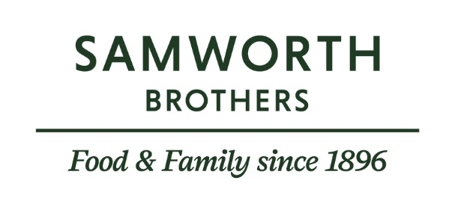

ROLE PROFILE
JOB TITLE | Senior Process Development Technologist
BUSINESS | Walker & Son
DEPARTMENT | Technical
LOCATION | Leicester
DATE LAST REVIEWED | June 2026

ROLE SUMMARY
This role is responsible for leading the delivery of product launches and upgrades across multiple retail customers, ensuring seamless transition from concept to launch. The position oversees a small team of technologists, manages critical paths, and ensures products are scaled up accurately in line with specifications, quality standards, and customer expectations.

The role plays a key part in cross-functional collaboration with NPD, manufacturing, technical, and commercial teams, driving continuous improvement initiatives while maintaining high technical and food safety standards. Acting as a key interface with customers, the role requires strong project management, communication, and leadership skills to deliver against tight timelines and evolving business needs.

REPORTING STRUCTURE
REPORTS TO | Process Development Manager
DIRECT AND INDIRECT REPORTS | Process Development Technologists
KEY INTERNAL STAKEHOLDERS | Development, Commercial, Process Manager, Operations, Planning, Finance, Engineering and wider technical team.
KEY EXTERNAL STAKEHOLDERS | Customers

KEY ACCOUNTABILITIES AND RESPONSIBILITIES
- Act as a deputy for the Process Development Manager when required, ensuring the completion of weekly tasks and representing the team in relevant meetings.

- Ensure compliance with all site and group Health and Safety and Food Safety procedures and policies, proactively addressing non-compliance and escalating issues to the appropriate department when necessary.

- Escalation of risk to the business reputation, product launches or relationship with customers to the Process Manager.

- Provide leadership and guidance to a team of Process Technologists to ensure critical project timelines and customer deadlines are achieved.

- Actively foster the achievement of individual development plans for direct reports through frequent 121s.
- Independently manage products from handover to launch.

- Ensure accurate scale-up of products in line with specifications, including execution of line manuals, QAS, and line standards.

- Management and maintenance of customer relationships ensuring updates are provided in line with key milestones.
- Accountable for ensuring all key process documentation is accurately maintained and kept up to date.

QUALIFICATIONS, EXPERIENCE, TECHNICAL SKILLS / KNOWLEDGE
- Degree or equivalent qualification in a science-based subject is preferable. If not degree qualified, then minimum requirement – Food Safety Level 3.
- Previous experience as Process Development Technologist or management of customers essential.
- Good working knowledge of computer systems – ability to use Word, Excel, and PowerPoint
- Organisational / prioritisation skills & ability to respond rapidly to changes in priorities.
- Effective communication skills with external stakeholders.
- Ability to ensure attention to detail even when under pressure.
- Excellent team working skills.
- Problem solving & decision-making skills.
- Must be competent in written English and basic Maths.
- Ability to negotiate, influence & recognise others’ viewpoints.
- Ability to develop effective relationships with other areas across site.
- Ability to work unsupervised & on own initiative with a varied workload.
- Full driving Licence required.

CORE COMPETENCIES, ATTRIBUTES & BEHAVIOURS FOR SUCCESS
Competency | Descriptors
Values People | Demonstrates the belief that people are our most important asset and central to the success of the organisation. Everybody should be treated with dignity and respect at all times.
Customer Focus | Demonstrates the understanding that the satisfaction of our internal and external customers is the foundation of our success
Collaborative Team Working | The willingness to act as part of a team and work towards achieving shared objectives through adopting best practice in line with PQP and Federalism.
Flexibility & Adaptability | The ability to change and adapt own behaviour or work procedures when there is a change in the work environment, for example as a result of changing customer needs.
Initiative & taking ownership | Steps up to take on personal responsibility and accountability for tasks and actions in line with PQP and Federalism.
Drive for Excellence | Knows the most effective and efficient processes for getting things done, with a focus on continuous improvement.
Resource Management | Effectively manages resources and cost drivers to achieve sustainable productivity and profitability.
Technical Expertise | Has the skills, knowledge and experience required to excel in own area of specialism and the willingness to further grow and develop.
Self-Management | Uses a combination of feedback and reflection to gain insight into personal strengths and weaknesses, so that own time, priorities and resources can be managed to achieve goals.

