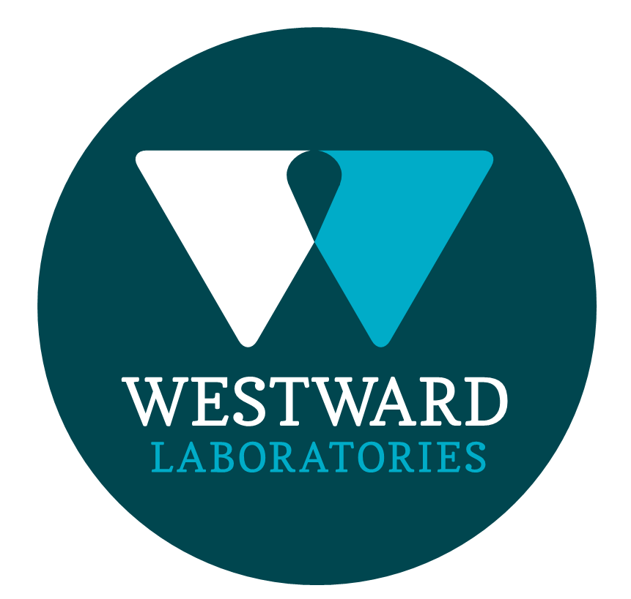

ROLE PROFILE
Job Title | Laboratory Manager
Department | Management
ROLE SUMMARY
To assist the General Manager in ensuring that microbiological testing and laboratory operations are carried out in accordance with WL policies and procedures as set out in the Microbiology and Quality Manuals and in accordance with customer requirements set out in the Customer Requirements File. To ensure that the accreditation requirements of ISO 17025, and the Campden BRI Retailer Supplementary Audit (RSA) Scheme are followed at all times. Responsibility for laboratory operations, methods and equipment. Assist the General Manager with health and safety duties.

REPORTING STRUCTURE
Reports to | General Manager
Direct & indirect reports | Direct - Microbiology Manager, Customer Services Manager, Quality Control Analyst / Indirect - All WWL Employees
Key internal stakeholders | All departments within Westward and the wider Samworth Brothers Group
Key external stakeholders | External Customers, Accreditation Bodies, Service Providers, Consumable Suppliers
Deputy | Microbiology Manager, Customer Service Manager and Quality Manager

KEY ACCOUNTABILITIES AND RESPONSIBILITIES
- To oversee all areas and operations of the laboratory. To ensure that microbiological testing is carried out in accordance with customer requirements as set out in the Customer Requirements File.
- Participate in developmental, investigational and validation work relating to existing and new methods, ensuring that methods are fit for purpose.
- Participate in quarterly method performance reviews and complete associated actions as necessary.
- Perform annual method reviews according to a defined schedule, circulating the completed reviews to the General Manager.
- To work alongside the QM manager and internal QS systems, ensuring that any failures are acted on appropriately by relevant personnel.
- To plan and co-ordinate induction programme for new employees and to provide training as indicated in the relevant General Training Schedule.
- Book internal training courses for Westward Candidates. Issue the pre-course briefs and pass to Quality Systems when complete.
- Engage with suppliers, ensuring good relationships, service levels and costs are maintained
- Actively engage with external industry bodies as required. Ensure dissemination of information is completed as required
- Oversee the collation of report of out of specifications results to customers ensuring the laboratory procedures and customer requirements are complied with.
- Oversee the communication of suspect and detected Listeria and Salmonella results and deal with anomalous results as appropriate.
- Authorise and release sensitive results, liaising with and advising customers where necessary.
- Lead and motivate Managers promoting communication between all departments and between weekend and weekday staff.
- Ensure effective supervision of subordinates at all times, managing disciplinary procedures where necessary.
- Arrange PDPs with staff, setting objectives and reviewing progress at regular intervals. Follow the absence procedure and communicate to relevant parties when people are off sick. Be aware of the businesses disciplinary procedure and implement when necessary.
- Participate in the staff recruitment ensuring individuals of the correct calibre are employed.
- To complete all relevant documentation for new starters ensuring that contracts etc. are sent out promptly.
- Deputise for the General Manager as required
- Ensure that all accountable areas are managed within the financial and budgeted resources at all times.
- Communicate relevant information concisely and proficiently to the team.
- Maintain good relations with laboratory customers and visit customers where necessary.
- Where appropriate, participate in board meetings; communicate the key issues of the laboratory.
- Be responsible for health and safety in the department and enforce safe practices of work and participate in the management of risk assessments and COSHH
- Promote a culture of health and safety within the laboratory, ensuring a safe working environment for all colleagues
- Participate in managers’ meetings, raising issues, problem-solving and dealing with queries as they arise. Communicating back to senior management where relevant.
- Ensure building security in accordance with the company policy, leaving the building locked and alarmed at the end of the day

QUALIFICATIONS, EXPERIENCE, TECHNICAL SKILLS / KNOWLEDGE
- Degree, HND or equivalent in science-based subjects is preferred
- Proven management experience
- Technical food microbiology experience
- Computer Literate
- Project management experience
- Proven track record of managing teams to include experience in the completion of staff appraisals and staff performance.
- Proven track record in cost control, health & safety, departmental quality systems and change management.
- Supervisory/Management Experience
- Current Driving Licence

COMPETENCIES, ATTRIBUTES & BEHAVIOURS FOR SUCCESS
CORE WAYS OF WORKING
Competency | Descriptor
Values People | Demonstrates the belief that people are our most important asset and central to the success of the organisation. Everybody should be treated with dignity and respect at all times.
Customer Focus | Demonstrates the understanding that the satisfaction of our internal and external customers is the foundation of our success
Collaborative Team Working | The willingness to act as part of a team and work towards achieving shared objectives through adopting best practice in line with PQP and Federalism.
Flexibility & Adaptability | The ability to change and adapt own behaviour or work procedures when there is a change in the work environment, for example as a result of changing customer needs.
Initiative & taking ownership | Steps up to take on personal responsibility and accountability for tasks and actions in line with PQP and Federalism.
SENIOR LEADER
Competency | Descriptor
People Management | The ability to understand people and their motivations, build good relationships with them and help them unlock their potential.
Decision making and judgement | In line with our guiding principles of PQP & Federalism, makes timely and informed decisions that take into account the facts, goals, constraints and risks that keep the organisation moving forward.
Commercial awareness | Demonstrates an understanding of the impact decisions and actions have on the organisation in line with PQP and Federalism.
Developing partnerships | The ability to establish formal and informal relationships inside and outside the organisation, and to anticipate and balance the needs of those whose cooperation is needed for the long-term success of the business.
Engaging others through change | The ability to communicate a compelling vision throughout the organisation, generating genuine motivation and commitment and to act as a sponsor of change.
Focussing on the future | Demonstrates enthusiasm about our future by identifying strategic issues, opportunities to drive sustainable, profitable growth, and managing risk.

A signed copy of this document is held in the training record
Signed by Laboratory Manager | Date

