- Role Description

Job Title: | Site Service Team Leader
Location: | Saladworks
Division: | Meal Division

Role Definition: (Summarise the purpose of the role and the contribution this job makes to the organisation’s purpose – what is it here to deliver).
To efficiently manage the engineering functions of the site and to play an active role in supporting the business ensuring Health and safety is at the forefront of systems and decisions.
People Responsibility (structure below)
Deliver engineering KPI’s to improve performance and overall site efficiencies.

Reporting Relationships: (Insert an organisational chart showing where this job sits and the jobs immediately around it).
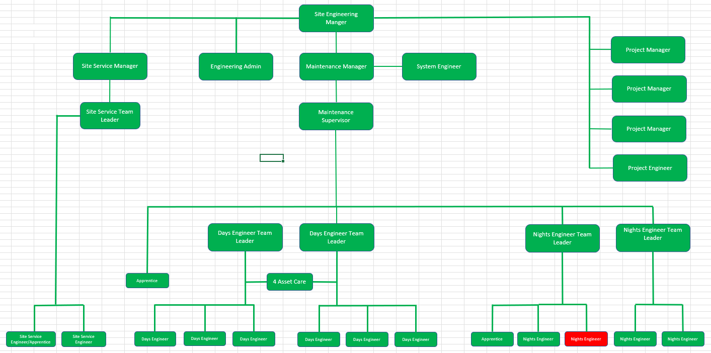

Accountabilities: ( 6 to 8 statements identifying the principal outputs required of the job in order to deliver its purpose).
- Reporting into and supporting Site Service Manager in attaining site objectives.
- Demonstrate a high engineering profile on customer visits, audits, and initiatives
- Breadth of knowledge and understanding the business (factories etc) – focusing on site efficiency and health and safety objectives. Engaging others and working in the greater team to understand requirements of the total business therefore ensuring alignment of goals.
- Working with and engaging others to find opportunities to challenge and develop the performance of the department to improve the overall performance of the site.
- To actively promote a safety culture within the factory ensuring all Health & safety requirements are met.
- Ensure contractor controls and legislative compliance is in place.
- To order and maintain an appropriate level of replacement stocks.
- Manage the engineering team leaders and be responsible for their performance and development.
- To collate and deliver a weekly summary of KPI’s
- Drive the continuous improvement of the culture, people, and practices within the business, ensuring a position of market leader rather than follower.
- To maintain & operate an effective PPM system. Reporting progress routinely.
- Deliver value initiatives to meet internal targets.
- Liaise with Operations Area Manager/Manufacturing Manager on strategic engineering matters.
- To ensure hygiene and technical standards are met and that employees adhere to hygiene regulations
- Support and lead the tier process.
Competency Requirements: (Delete tick where competency doesn’t apply).
Values required from team: | Honesty, Passion, Determination, Loyalty.
Resilience | Never gives up. Relentless, proactive focus on reducing HS risks. Meet or exceeds targets without being asked.
Brilliant Execution | Use thinking skills to analyse, decide, prioritise and plan. Can balance short term requirements with long term objectives to achieve goals.
Communication and Influencing Skills | Able to influence people at all levels, internal and external, through listening and adjusting communication style to meet the needs of the audience.
Customer Focused | Understands the customer better than anyone else in the business. Always seeking to improve quality and service for our internal / external stakeholders.
Team Player | Works with colleagues to do what is best for the Company as a whole, ahead of divisional, department or personal goals.
Leadership | Puts the team first. Owns results of self and team. Inspires others to follow through involvement, coaching, setting direction and performance standards.
Knowledge / Skills / Qualifications: (What skills, qualifications and experience are necessary for FULL and EFFECTIVE performance?)

Relevant qualification in Mechanical/Electrical engineering
Strong planning and organising ability
Ability to prioritise and work effectively under pressure. Highly developed communication skills (verbal, written, listening, influencing). Excellent coaching and training skills. Experience and proven ability in managing people and tasks.
Self motivated and proactive approach to work.
Awareness of Health and Safety and other relevant legislation
Ability to communicate to all levels within the business

Decision Making
- Deputise for the Site Service Manager during his absence.
- To provide support and advice to engineering team and operational managers where appropriate.
- Exercise disciplinary to dismissal level .

