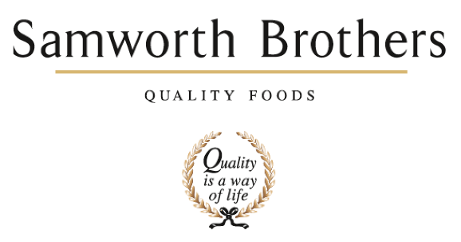

ROLE PROFILE
Job title | Process Technologist – CI | Date | 22/12/2025
Business | Samworth Brothers Meals
Department | Process Development – Technical
Location
ROLE SUMMARY
Ownership of validations throughout the process department and annual refreshers thereafter.
Continuous improvement support to review optimum processes to include cooking and cooling optimisation to reduce cost and maintain or improve quality.
Support the Meals Environmental Manager on all responsible business projects requiring trial work.
REPORTING STRUCTURE
Reports to | Process Development Manager
Direct & indirect reports | N/A
Key internal stakeholders | Production, Process, CI, Planning, Finance, Technical Services, QA, Commercial and Meals Environmental Manager
Key external stakeholders | Retailers (project dependant), Suppliers (project dependant)

KEY ACCOUNTABILITIES AND RESPONSIBILITIES
- Adherence to critical paths in line with the Samworth Brothers Launch Process
- Prepare documentation and liaise with manufacturing functions for the planning of trials
- Conduct factory trials in conjunction with customer COP’s, including the capturing of traceability and trial data
- Conduct full worst case scenario validation studies to ensure safety criteria’s are consistently achieved
- Conduct annual refresher validation studies
- Work with CI on delivery of site PIP’s – sole ownership
- Organise post-trial outputs to include; initiation of BOM’s, completion of product specific documentation, organisation of samples for microbiological & chemical testing, customer samples and organoleptic testing
- Assist and where necessary provide cover for the Process Technologists on day to day management of projects
- Working collaboratively with the wider business to provide support in process matters
Maintain high technical and quality standards in line with the businesses policies and procedures

QUALIFICATIONS, EXPERIENCE, TECHNICAL SKILLS / KNOWLEDGE
- Working knowledge of Food Manufacturing practices, ideally FMCG
- Understanding of customer concept to launch protocols
- Collaborative team worker and able to work on own initiative
- Excellent written and verbal communication skills at all levels
- Self motivated, enthusiastic and able to work well under pressure
- Good IT skills with experience of using MS Excel, Word, PP & Outlook
- Strong organisational and planning skills
- Flexible approach to working hours and business demands
- Understanding of HACCP application and considerations (including validation requirements)
- Thermal processing qualifications (desirable)
- Driving license (desirable)
- HND/BSc, preferably Food Science (desirable)
- Minimum of 12 months working experience within chilled food manufacturing, ideally within a process or NPD function (desirable)
CORE COMPETENCIES, ATTRIBUTES & BEHAVIOURS FOR SUCCESS
Competency | Descriptors
Values People | Demonstrates the belief that people are our most important asset and central to the success of the organisation. Everybody should be treated with dignity and respect at all times.
Customer Focus | Demonstrates the understanding that the satisfaction of our internal and external customers is the foundation of our success
Collaborative Team Working | The willingness to act as part of a team and work towards achieving shared objectives through adopting best practice in line with PQP and Federalism.
Flexibility & Adaptability | The ability to change and adapt own behaviour or work procedures when there is a change in the work environment, for example as a result of changing customer needs.
Initiative & taking ownership | Steps up to take on personal responsibility and accountability for tasks and actions in line with PQP and Federalism.
Drive for Excellence | Knows the most effective and efficient processes for getting things done, with a focus on continuous improvement.
Resource Management | Effectively manages resources and cost drivers to achieve sustainable productivity and profitability.
Technical Expertise | Has the skills, knowledge and experience required to excel in own area of specialism and the willingness to further grow and develop.
Self-Management | Uses a combination of feedback and reflection to gain insight into personal strengths and weaknesses, so that own time, priorities and resources can be managed to achieve goals.

