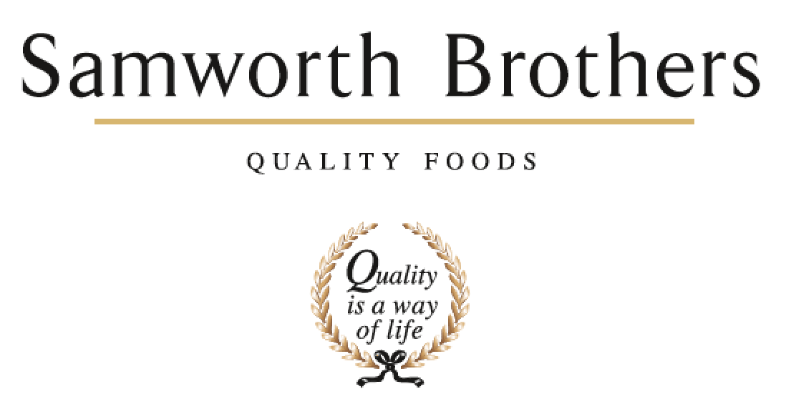

ROLE PROFILE
Job title | Compliance Technologist | Date | November 2024
Business | Bradgate Bakery
Department | Technical
Location | Madeline Road / Ashton Green
ROLE SUMMARY
To ensure that all aspects of food safety, quality and legality for the products manufactured are complied with ensuring that the technical integrity of the site is maintained.

REPORTING STRUCTURE
Reports to | Senior Quality Systems Technologist / Compliance Manager
Direct & indirect reports | None
Key internal stakeholders | QA Departments, Technical Managers, Process Team, Specifications team, Production, Commercial
Key external stakeholders | All customers – quality of data

KEY ACCOUNTABILITIES AND RESPONSIBILITIES
  - Prioritise and multitask work set on daily basis.
  - To update Technical Systems to allow the production of safe, legal and high-quality products.
  - Weekly and monthly Technical and customer KPI data collation, including trending of data, to be accurately completed and issued when required.
  - To keep trending systems up to date and in working order.
  - To ensure the coding schedule is correct and issued on time.
  - To ensure complaints are logged and shared with the site QA teams, and all responses are typed and communicated back to customers.
  - Monitoring of Customer Retail Systems – monitor all alerts and customers testing results, ensuring any surveillance fails are communicated to the appropriate teams.
  - To provide support to the specification’s teams for ad-hoc spec updates and artwork checks.
  - Maintenance of internal audits and fabric audits schedules ensuring any non-conformances raised are logged.
  - Data input into various technical trackers to include micro results, nutritional and corrective actions.
  - To ensure the nutritional trackers remain up to date and inform the QA teams of adverse results.
  - Update, amend and issue Technical Paperwork as and when required.
  - To support preparation of presentations for Technical KPI meetings when required and generation of ad hoc presentation packs, trending reports, summary reports as required
  - To ensure document control is completed effectively and in a timely manner.
  - Internal auditing team member
  - Keep packaging databased up to date
  - Sign off packaging specifications
  - Set up documents ready for gap analysis for BRC and customer requirements
  - Maintain up-to-date knowledge of food law, industry standards, and customer codes of practice.

QUALIFICATIONS, EXPERIENCE, TECHNICAL SKILLS / KNOWLEDGE
- Excellent knowledge of MS Office – Word / Excel / PowerPoint
- Excellent verbal and written communication skills
- Effective planning and organization skills
- Works in an accurate / logical / methodical manner
- Continually challenges / drives standards forward
- Good working knowledge of IT systems and on-line retailer portals
- General technical knowledge
- Excellent knowledge of Power Bi - preferred
- Experience in a Technical System role in chilled food manufacture - preferred

CORE COMPETENCIES, ATTRIBUTES & BEHAVIOURS FOR SUCCESS
Competency | Descriptors
Values People | Demonstrates the belief that people are our most important asset and central to the success of the organisation. Everybody should be treated with dignity and respect at all times.
Customer Focus | Demonstrates the understanding that the satisfaction of our internal and external customers is the foundation of our success
Collaborative Team Working | The willingness to act as part of a team and work towards achieving shared objectives through adopting best practice in line with PQP and Federalism.
Flexibility & Adaptability | The ability to change and adapt own behaviour or work procedures when there is a change in the work environment, for example as a result of changing customer needs.
Initiative & taking ownership | Steps up to take on personal responsibility and accountability for tasks and actions in line with PQP and Federalism.
Empowering others | Creates an environment where people feel required and enabled to take ownership and responsibility.
Analysis & Planning | The ability to take a range of information, think things through logically and prioritise work to meet commitments aligned with organisational goals.
Drive for Excellence | Knows the most effective and efficient processes for getting things done, with a focus on continuous improvement.

