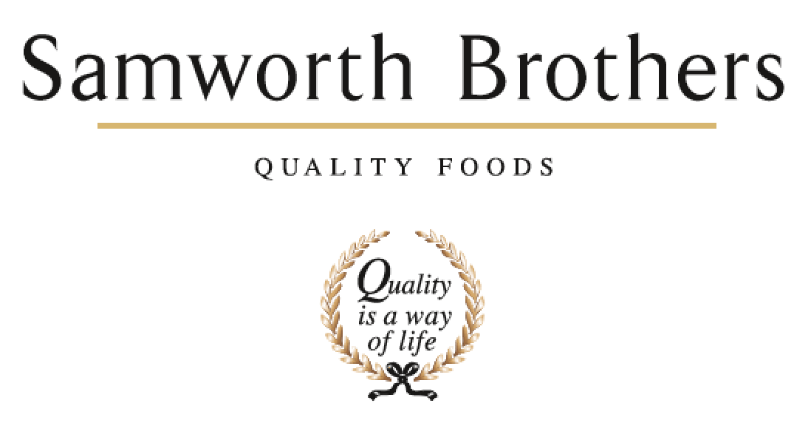

ROLE PROFILE
Job title | Packaging Technologist | Date | Oct 2025
Business | The Cornwall Bakery
Department | Technical
Location | Callington
ROLE SUMMARY
Responsible for the delivery of new artwork, packaging and labels as required through our product Critical Path plans. A keen eye for detail is required and a willingness to learn. Full training will be given with the opportunity and support for external qualifications relating to the role.
REPORTING STRUCTURE
Reports to | Process Manager
Direct & indirect reports | N/A
Key internal stakeholders | Operations Team, Technical Team, NPD Team, Purchasing Team
Key external stakeholders | All retail and brand customers

KEY ACCOUNTABILITIES AND RESPONSIBILITIES
Key responsibilities/Accountabilities

- Day to day issue resolution on packaging or support on supply issues where necessary
- Maintain and development relationships with all existing and potential suppliers.
- Attend weekly meetings where necessary such as NPD, critical path and launch meetings.
- Follow new materials from concept through to launch to ensure any changes / feedback to suppliers is captured.
- Review and evaluate current packaging designs to ensure continuous improvement/developments
- Liaise with packaging design companies on all packaging related matters to ensure swiftly resolved and working to correct customer specification.
- Monitor current and future trends in packaging/packaging manufacturing technology/machinery to ensure business is at the forefront in technology.
- Design all NPD packaging that complies with all UK and EU requirements
- Manage the artwork process and work with Process to achieve NPD timelines for customers and ensure process complete bakery trials.
- Produce keylines for all new products
- Represent the company at customer artwork meetings to ensure that the designs comply with the print process and bakery’s requirements
- Attend pass on press for first print runs to ensure quality standards are met
- Set up pallet plans for any new outer cases
- Issue of New Product Launch packaging briefs to business
- Responsible for reacting to feedback from the Bakery and Engineering teams regarding existing packaging and any issues / improvements. Issue Non-conformances to the suppliers of material when required.
- Yearly Valpack submission details / EPR / RAM / Supplier 3rd party / Customer related packaging essential requirements.
- Maintenance of packaging specifications and packaging database, including Supplier Audit status and risk rating.
- Support Commercial Team with packaging innovation / projects
- Innovation – research and present packaging innovation presentations to customers
- Customer meetings
- Samples / mock ups

QUALIFICATIONS, EXPERIENCE, TECHNICAL SKILLS / KNOWLEDGE
- This role requires strong communication skills (written & Verbal) with respect to the content and quality of the communication, as well as delivery method - verbal and written communication form the backbone of this role.
- Good attention to detail.
- Planning and organisational skills.
- Professional approach.
- Calm & measured approach in an often pressured environment which often involves working to tight deadlines.
- A “can do” attitude and “hands on” approach.
- Ability to approach things pragmatically and consider solutions that deliver on different levels to the business (eg: no detriment to quality, keeping on-cost down, within specification and in time).
- Able to use own initiative to identify and act on business opportunities
- Full Driving license and the willingness to travel within the UK and potentially within the EU.
- Microsoft literate (particular use of Excel, Word, Outlook and Powerpoint)

CORE COMPETENCIES, ATTRIBUTES & BEHAVIOURS FOR SUCCESS
Competency | Descriptors
Values People | Demonstrates the belief that people are our most important asset and central to the success of the organisation. Everybody should be treated with dignity and respect at all times.
Customer Focus | Demonstrates the understanding that the satisfaction of our internal and external customers is the foundation of our success
Collaborative Team Working | The willingness to act as part of a team and work towards achieving shared objectives through adopting best practice in line with PQP and Federalism.
Flexibility & Adaptability | The ability to change and adapt own behaviour or work procedures when there is a change in the work environment, for example as a result of changing customer needs.
Initiative & taking ownership | Steps up to take on personal responsibility and accountability for tasks and actions in line with PQP and Federalism.
People Management | The ability to understand people and their motivations, build good relationships with them and help them unlock their potential.
Empowering others | Creates an environment where people feel required and enabled to take ownership and responsibility.
Coaching for performance | The ability to help others achieve more through two-way feedback, clear direction and enabling.
Analysis & Planning | The ability to take a range of information, think things through logically and prioritise work to meet commitments aligned with organisational goals.
Drive for Excellence | Knows the most effective and efficient processes for getting things done, with a focus on continuous improvement.

