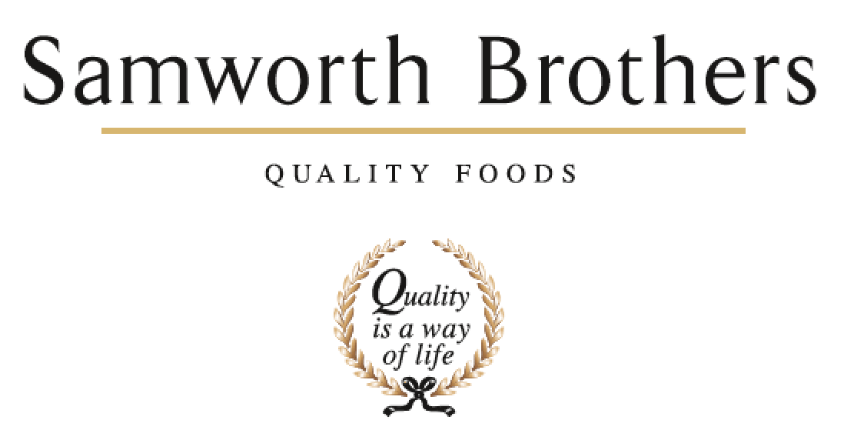

ROLE PROFILE
Job title | Executive Assistant to the MD & Category Leadership Team | Date | Jan 2026
Business | Samworth Brothers
Department | CLT
Location | Meals
ROLE SUMMARY
- Your primary responsibility will be providing seamless, executive-level support to the MD & CLT across Meals.
- You will be responsible for the coordination of confidential calendar, inbox, travel management and event planning & hosting.
- You must ensure that all correspondence and requests effectively utilise the MD & CLT time by showing initiative to schedule meetings and events and assist as required on high-level projects and varied administrative tasks proactively and proficiently.
- Your role will be to think several steps ahead, anticipating what is needed and what the MD & CLT needs to be successful.
- You will be confident in operational report writing and producing executive level presentations ensuring the provision of meeting packs to the MD & CLT, so that they are fully prepared for all meetings and appointments
- Support regulatory audits and documentation (HACCP, GMP, BRC, SQF, ISO).
- This is a pivotal role that demands exceptional time management and organisational skills, an eye for detail and respect of confidentiality, a proactive and flexible attitude and ability to work autonomously in a stakeholder-dynamic environment.
- This role will require the organisation and planning of some personal administration and logistics to enable the MD & CLT to be fully focussed on delivering their role to the full
- You will need to have proven exceptional planning and organising skills with the ability to flex your thinking to the short, medium and long term to ensure that there is a seamless execution of activities, deadlines and responsibilities.
- Additionally, your ability to quickly build strong professional relationships are crucial in your day-to-day interactions across the business.
- You will need to be collaborative and demonstrate initiative and drive in order to connect with people across the organisation and externally in a professional, engaging and productive manner
- Working collaboratively with the wider business PA & EA Network to agree fit solutions for delivering big events and ensuring efficiency in ways of working.
REPORTING STRUCTURE
Reports to | Managing Director
Direct & indirect reports | None
Key internal stakeholders | Category Leadership Team  Site Leadership Teams  PA & EA Community  GEB
Key external stakeholders | Visitors  Senior Customers  Colleagues

KEY ACCOUNTABILITIES AND RESPONSIBILITIES
This is not an exhaustive list and the role will require you to accept additional responsibilities.

- Intelligent Diary & Inbox Management – MD & CLT
- Organisation & set up of internal and external meetings, visits and Off Site Events that the MD & CLT are required to organise, to include, catering, conference facilities, booking parking, room bookings etc.
- Video Conferencing Setup & troubleshoot
- Note Taking, Agenda Writing, Governance Management, Meeting Management, Action Management
- Administrative support for the MD & CLT to include, Presentation preparation, letters, minutes, agendas, action management, email responses, expenses processing,
- Travel arrangements and hotel bookings
- Arranging car services and tyre checks and vehicle maintenance for the CLT
- Management of MD & CLT Holiday tracking
- Preparation and Coordination of Presentations, Slide Decks, Board Packs etc.
- Management of the Meals CLT asset bank in conjunction with the Communications Partner.
- Supporting the Communications Partner on key communications and announcements on behalf of the MD & CLT
- Technically experienced with MS365 including Teams, Excel, PowerPoint, Word, Outlook
- Other Administration required i.e. letter writing, reporting writing
- Building collaborative relationships with key stakeholders both internally and externally to deliver a seamless PA experience to the MD & CLT

QUALIFICATIONS, EXPERIENCE, TECHNICAL SKILLS / KNOWLEDGE
- Excellent Microsoft skills, Excel, Word, Powerpoint, Outlook
- Excellent organisational skills, attention to detail and ability to work to tight deadlines.
- Ability to constantly look ahead, assessing potential challenges and working collaboratively with internal and external stakeholders to mitigate problems before they arise.
- Ability to multi-task and operate effectively within a fast-paced environment.
- Proactive, can-do attitude.
- Excellent team player
- To be eligible to work in the UK.
- There will be a requirement to be able to work virtually and from different locations as needed across the Meals business as well as from external business locations as is required.
- Physical presence and accessibility is important as and when the MD is in the office.

CORE COMPETENCIES, ATTRIBUTES & BEHAVIOURS FOR SUCCESS
Competency | Descriptors
Values People | Demonstrates the belief that people are our most important asset and central to the success of the organisation. Everybody should be treated with dignity and respect at all times.
Customer Focus | Demonstrates the understanding that the satisfaction of our internal and external customers is the foundation of our success
Collaborative Team Working | The willingness to act as part of a team and work towards achieving shared objectives through adopting best practice in line with PQP and Federalism.
Flexibility & Adaptability | The ability to change and adapt own behaviour or work procedures when there is a change in the work environment, for example as a result of changing customer needs.
Initiative & taking ownership | Steps up to take on personal responsibility and accountability for tasks and actions in line with PQP and Federalism.
People Management | The ability to understand people and their motivations, build good relationships with them and help them unlock their potential.
Flexibility & Adaptability | The ability to change and adapt own behaviour or work procedures when there is a change in the work environment, for example as a result of changing customer needs.
Drive for Excellence | Knows the most effective and efficient processes for getting things done, with a focus on continuous improvement.
Resource Management | Effectively manages resources and cost drivers to achieve sustainable productivity and profitability.
Drive for Excellence | Knows the most effective and efficient processes for getting things done, with a focus on continuous improvement.
Technical Expertise | Has the skills, knowledge and experience required to excel in own area of specialism and willingness to further grow and develop.

