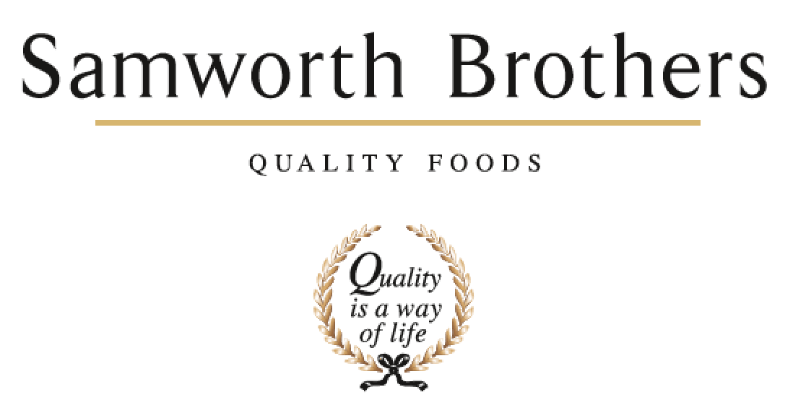

ROLE PROFILE
Job title | Process Manager | Updated: | March 2026
Business | Walkers Charnwood
Department | Technical
Working Hours | Monday to Friday 08:30-17:00
Location | On Site, Charnwood Bakery, Leicester.
ROLE SUMMARY
Responsibility for management and co-ordination of all Process Development activities for Walkers Charnwood.

To manage the successful launch of all new and reformulated products at Walkers Charnwood ensuring the safety, quality and legality of the products at all stages of the process.

To lead, inspire and motivate the Process development team.

To continuously improve and lead on improvements to the business concept to launch process.

Reports to | Technical Manager
Direct & indirect reports | Senior Process Techs and Process Technologists
Key internal stakeholders | Production, Planning, Finance, Technical Services, Technical Systems, QA and Commercial
Key external stakeholders | Retailers, Suppliers (project dependant)

KEY ACCOUNTABILITIES AND RESPONSIBILITIES
- Effective planning and management of the process team as a key business resource and function. Leadership of effective trials.
- Manage all parts of the NPD process for Walkers Charnwood following handover from the NPD team up to the point of launch including any reformulation of existing products.
- Management of the maintenance of required trial records. This will include all information required for recipes, specifications and costings. Ensure a ’Product File’ is completed for each product and that data is provided for the final product specification within relevant time scales including technical requirements and in accordance with the customer and site critical path.
- Manage the interaction with the finance department in providing information to achieve accurate product costings, communicating any NPD or EPD recipe changes.
- Set standards for the effective management and planning of customer pre-production visits and launches.
- Liaise closely with the technical teams, purchasing teams and finance teams to achieve technical compliance for all products, ensure raw materials and ingredients are ordered on time, technical validation of micro and shelf life.
- Ensure as a team communication is effective with the customer on all Process Development activities in line with the agreed critical path.
- Collaborative working with other site functions (predominantly QA, Purchasing, NPD, Technical Services and Operations) to ensure product launches and projects are delivered accurately and on time.
- Management of projects related to a change in existing processes, equipment or raw materials.
- Participate in projects that add value to our overall business as required.
QUALIFICATIONS, EXPERIENCE, TECHNICAL SKILLS / KNOWLEDGE
- Degree in food related subject or equivalent job related experience
- Intermediate HACCP
- Thermal processing validation experience.
- Chilled / Short Shelf Life experience.
- Multiple major retailer experience.
- Food labelling.
- Experience with customer web portals
- Excellent organisational skills.
- Good interpersonal/team management skills
- Microsoft Office.
- Ability to negotiate, influence and recognise other viewpoints.
- Ability to work unsupervised and on own initiative with varied workload.
- Ability to develop effective relationships with other teams across sites.
CORE COMPETENCIES, ATTRIBUTES & BEHAVIOURS FOR SUCCESS
Competency | Descriptors
Customer Focus | Demonstrates the understanding that the satisfaction of our internal and external customers is the foundation of our success.
People Management | The ability to understand people and their motivations, build good relationships with them and help them unlock their potential
Drive for Excellence | Knows the most effective and efficient processes for getting things done, with a focus on continuous improvement.
Initiative & Taking Ownership | Steps up to take on personal responsibility and accountability for tasks and actions in line with PQP and Federalism.
Flexibility & Adaptability | The ability to change and adapt own behaviour or work procedures when there is a change in work environment, for example as a result of changing customer needs.

Please sign and date this document to confirm your understanding of the role profile. | Signature:  Date:

