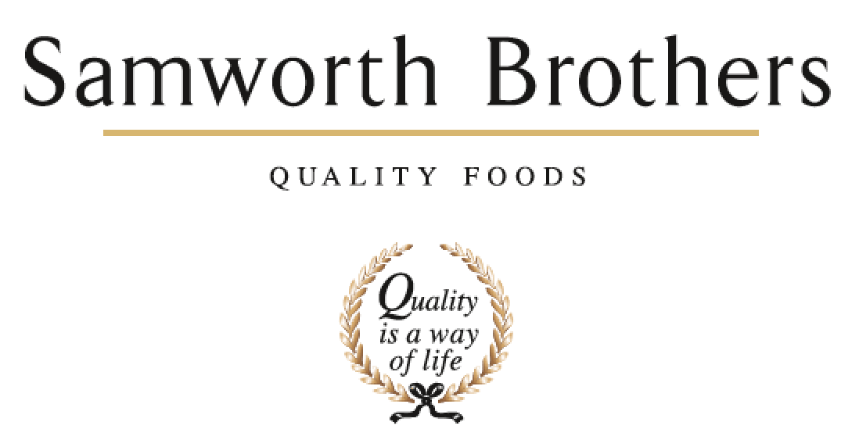

ROLE PROFILE
Job title | Supply Chain Manager (Transformation) | Date | August 2025
Business | Meals
43Department | Supply Chain
Location | Multi-site
ROLE SUMMARY
The Supply Chain Manager will lead the alignment and transformation of supply chain processes across the Category ensuring consistency, integration, and adoption of best practices in line with the Groups strategic direction. This role is pivotal in driving a step change in supply chain performance, standardisation, and capability. It will focus on embedding common frameworks, systems and ways of working across the sites to create a more agile, resilient and cost-effective supply chain. The role will focus on harmonising planning, procurement, logistics, inventory management and people across both sites ((Plan, Make, Source, Deliver & People)) to drive operational excellence and cost efficiency.
REPORTING STRUCTURE
Reports to
Direct & indirect reports | Direct: Site Supply Chain
Key internal stakeholders | Site Supply Chain teams, Site Directors & Operational Teams, Procurement, SBSC, IT and Digital, Ops Managers, Responsible Business, Technical / Group Supply Chain; Health and Safety & Environmental Teams,
Key external stakeholders | Customers, Suppliers,

KEY ACCOUNTABILITIES AND RESPONSIBILITIES
Category Supply Chain
- Lead transformation initiatives to harmonise supply chain processes (planning, procurement, logistics, inventory, people, systems) across Category, partnering with site leadership and group functions to design and implement standard operating models, governance, and performance management frameworks
- Driving cross site projects that improve efficiency and integration of end-to-end supply chain
- Building capability and driving a culture of continuous improvement to sustain long term transformation benefits
- Develop and own the S&OP process for the Category ensuring we are optimising both bakeries
- Think strategically and develop supply chain plans that align with the overall business strategy - this includes identifying opportunities for growth and improvement, anticipating challenges
- Support business growth and resilience through risk management and capacity planning
- Input into company / group decisions and initiatives, understand what they mean for the Category supply chain and organise appropriate actions or activities that represent the interests of the Category.
- Represent the Category supply chain in business decisions, forums & initiatives

- Work collaboratively with other departments and stakeholders to achieve common goals, this includes negotiating & influencing effectively.
- Build relationships and networks, identifying opportunities for collaboration, and communicating effectively to persuade others to act.
- Encourage innovation and change, help identify opportunities for improvement and implementing new initiatives.
- Communicate effectively with all levels of the organisation, conveying information, goals, and expectations clearly and concisely.
- Ability to influence and persuade others through effective communication and interpersonal skill - build consensus and gain buy-in from a wide group of stakeholders, categories & functions.
- Strong leadership skills, with the ability to motivate and inspire others towards a common goal.
- Ability to remain flexible and open-minded, while still maintaining focus on key objectives.
- Be comfortable to work where success is not clearly defined or easily measurable.
- Understand the change between a category-based operational role and group-level strategic role: Operational roles are focused on executing day-to-day tasks, while strategic roles are focused on long-term planning and decision-making.
- Manage the transition from an operational, task-based role with clear measures of success to a broader, strategic role, reliant on influence and credibility.

Workstream Lead (Plan, Make, Source, Deliver & People)
- Develop and maintain a product roadmap that aligns with the strategic goals and objectives.
- Drive delivery of plans, utilising network to secure the right inputs & teams, monitoring progress & course-correcting as needed.
- Represent supply chain-focus area (plan, source, make, deliver & people), align plans to the supply chain & Samworth vision.
- Conduct research and analysis to identify opportunities for growth and improvement inc. art of the possible utilising 3rd parties, as needed.
- Analyse market trends and competitive landscape to identify potential threats and opportunities.
- Develop and manage budgets and resource allocation for strategic initiatives.
- Lead cross-functional teams to execute on initiatives - providing guidance, support, and mentorship to team members.
- Lead the internal and external teams through the change, co-ordinating with managers of other areas to identify ways to maximise benefit and minimise any negative impact. Encourage the view that change is a necessary and valuable part of business progress.
- Pro-actively take on personal responsibility and accountability to fully understand challenges, seek solutions, and work collaboratively with the project.
- Be accountable for KPIs and measures used to drive results & track value.
- Understanding of the processes and practices of each department and how each may change in accordance with a new capability.
- Represent the organization externally, building and maintaining relationships with partners, clients, and other stakeholders.
- Continually look to improve own performance and capability by linking personal objectives to support the business and seeks learning and development opportunities.

As a leader
- Act as a role model for the Samworth Brothers Values and Ways of Working and encourage teams to share in our Purpose of “We do GOOD things with GREAT food”.
- Work collaboratively with the leaders and managers of the businesses across the group to build a values-based culture, delivering on the Culture Framework and ensuring that results are achieved with people at the heart of every decision, and consistent focus is given to providing a positive experience for Colleagues.
- Build good relationships ensuring everyone in all teams are treated equally and with respect. Ensure relations between departments involved are positive and build effective relationships with key internal and external stakeholders.
- Foster a positive and inclusive work environment, promoting collaboration, teamwork, and employee engagement.
- Monitor and evaluate performance, providing feedback and coaching to drive continuous improvement.
- Make informed decisions based on data, analysis, and sound judgment, considering the impact on the business as a whole and its stakeholders.
- Ensure compliance with relevant laws, regulations, and ethical standards in all aspects of the organization's operations – health & safety.
- Lead by example, demonstrating integrity, professionalism, and a strong work ethic in all interactions and decisions.
- Manage and resolve conflicts or issues that arise within the team or organization, promoting a positive and constructive resolution.

QUALIFICATIONS, EXPERIENCE, TECHNICAL SKILLS / KNOWLEDGE
- Have experience in change management and transformation (incl communication) experience.
- Have experience in external partner management and internal business stakeholder management.
- Management reporting & Analytics
- Risk management.
- Governance and process compliance
- Up to date and engaged in regulatory changes.
- Experience in supply chain Systems & technology. Incl. Advanced visualisation tools (Tableau, Qlik etc)
- Experience of successful delivery of technology transformation projects
- Experienced in Operations management.
- Budgeting, forecasting and cost management experience.
- Performance management using digital and AI solutions.
- Experience in Organisation and Talent Management
- Proven experience of a Collaborative approach to delivering change
- Strategic planning experience
- Strategic decision-making experience
CORE COMPETENCIES, ATTRIBUTES & BEHAVIOURS FOR SUCCESS
Competency | Descriptors
Values People | Demonstrates the belief that people are our most important asset and central to the success of the Organization. Leading with empathy creates a culture where everybody is always treated with dignity and respect and diversity of thought is encouraged.
Customer Focus | Is a leader in Customer Experience and can structure a business to create the right offer for our existing and future customers and consumers through insight and innovation.
Collaborative Team working | Demonstrates the ability to influence, persuade and collaborate across the Samworth Brothers Business and Group Functions to sustainable profitable growth for the Group
Flexibility & adaptability | Demonstrates the ability to create an agile organization that can respond quickly and efficiently to the changing environment
People Management | Demonstrates good emotional intelligence with the ability to build, develop and lead a great team and to understand people and their motivations, build good relationships with them and help them unlock their potential
Commercial Awareness | Demonstrates an understanding of the Commercial impact decisions and actions have on the Organization in line with our Group Purpose and Values.
Engaging others through change | Outstanding communicator with the ability to communicate a compelling vision throughout the organization, generating genuine motivation and commitment to deliver the change.
Focusing on the future | Demonstrates enthusiasm about our future by identifying strategic issues, opportunities to drive sustainable, profitable growth, and managing risk.
Developing Partnerships | The ability to establish formal and informal relationships inside and outside the organization, and to anticipate and balance the needs of all stakeholders whose cooperation is needed for the long-term success of the business.
Decision making & Judgement | Demonstrates the ability to deal with complexity and make timely and informed decisions that consider the facts, goals, constraints and risks that keep the Organization moving forward in line with our Group Purpose and Values.

