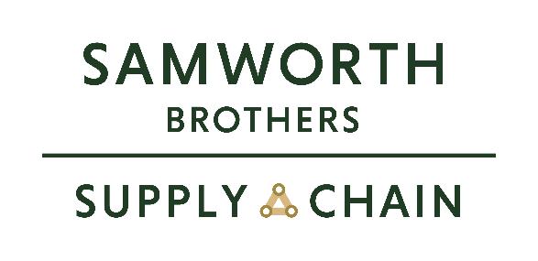

ROLE PROFILE
Job title | Facilities Supervisor | Date | Dec 2025
Business | Samworth Brothers Supply Chain
Department | Site Services
Location | Oak Meadow, Scudamore Rd, Leicester
ROLE SUMMARY
The Facilities Supervisor – Hygiene is responsible for managing and maintaining high standards of hygiene, cleanliness, and facility condition within a chilled distribution centre. The role ensures full compliance with food safety legislation, company standards, and audit requirements by overseeing cleaning operations, waste management, pest control, and hygiene-related maintenance activities. Working closely with operations, quality, and external service providers, the supervisor ensures that the chilled environment remains safe, compliant, and fit for purpose at all times.

Key accountabilities typically include supervising hygiene teams and contractors, scheduling and validating cleaning regimes, monitoring hygiene performance through inspections and KPIs, supporting internal and external audits, and driving continuous improvement in hygiene standards while maintaining cost and efficiency controls in a temperature-controlled environment.
REPORTING STRUCTURE
Reports to | Facilities Manager
Deputy
Direct & indirect reports | Hygiene Operatives
Key internal stakeholders
Key external stakeholders

ACCOUNTABILITIES
- Lead, manage, and develop the hygiene team to ensure consistent compliance with BRCGS Food Safety standards, site procedures, and customer requirements.
- Develop, implement, and maintain documented daily, weekly, and periodic cleaning schedules covering all internal and external areas, including chilled storage, handling areas, equipment, and welfare facilities.
- Ensure cleaning programmes are risk-based, validated, and effective.
- Conduct and document routine hygiene inspections, internal audits, ensuring non-conformances are identified, escalated, and closed out within agreed timescales.
- Maintain accurate, auditable records of hygiene activities, chemical usage, cleaning schedules, inspections, corrective actions, and verification checks in line with BRCGS traceability and record-keeping requirements.
- Work closely with Operations, Technical/Quality, and Health & Safety teams to manage hygiene risks, support food safety controls, and maintain audit readiness at all times.
- Ensure all cleaning chemicals, equipment, and processes are approved, correctly stored, labelled, and used in accordance with COSHH, supplier specifications, and site risk assessments.
- Support training, induction, and ongoing competency assessment of hygiene operatives, ensuring understanding of BRCGS principles, hygiene standards, and site procedures.
- Lead the response to hygiene-related incidents, or audit findings, carrying out root cause analysis and implementing effective corrective and preventative actions.
- Support external audits, customer visits, and regulatory inspections, acting as a key contact for hygiene-related elements of the BRCGS standard.

SKILLS, KNOWLEDGE & UNDERSTANDING
- Strong knowledge of food safety and hygiene legislation and best practice, including the safe handling, storage, and use of chemicals in accordance with COSHH requirements.
- Sound understanding of BRCGS Food Safety standards and their practical application within a chilled distribution or logistics environment.
- IOSH Managing Safely qualification preferred, or willingness to achieve within an agreed timeframe.
- Proven leadership and people management capability, with experience supervising, coaching, and motivating hygiene or facilities teams to deliver consistent standards.
- High level of attention to detail and a demonstrable commitment to maintaining and continuously improving hygiene and cleanliness standards.
- Effective communication and collaboration skills, with the ability to engage confidently with Operations, Technical/Quality, and Health & Safety stakeholders.
- Strong problem-solving and decision-making skills, with a proactive and structured approach to identifying, investigating, and resolving hygiene-related issues.
CORE COMPETENCIES, ATTRIBUTES & BEHAVIOURS FOR SUCCESS
Competency | Descriptors
Values People | Demonstrates the belief that people are our most important asset and central to the success of the organisation. Everybody should be treated with dignity and respect at all times.
Customer Focus | Is passionate about quality, striving to continuously make a positive difference for our customers and our consumers.
Collaborative Team Working | The willingness to act as part of a team and work towards achieving shared objectives through adopting best practice in line with our Purpose Statement and Company Values.
Flexibility & Adaptability | The ability to change and adapt own behaviour or work procedures when there is a change in the work environment, for example as a result of changing customer needs.
Initiative & taking ownership | Steps up to take on personal responsibility and accountability for tasks and actions in line with our Purpose Statement and Company Values.
People Management | The ability to understand people and their motivations, build good relationships with them and help them unlock their full potential.
Drive for Excellence | Knows the most effective and efficient processes for getting things done, with a focus on continuous improvement.
Resource Management | Effectively manages resources and cost drivers to achieve sustainable productivity and profitability.
Technical Expertise | Has the skills, knowledge and experience required to excel in own area of specialism and the willingness to further grow and develop.
Self-Management | Uses a combination of feedback and reflection to gain insight into personal strengths and weaknesses, so that own time, priorities, and resources can be managed to achieve goals.

