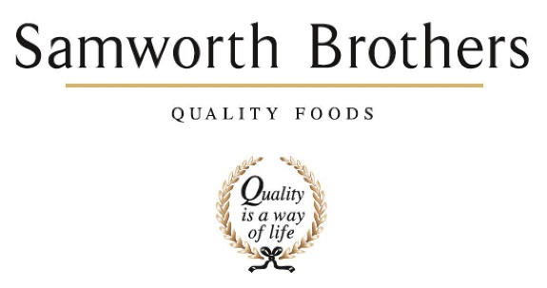

ROLE PROFILE
Job title | Environment Manager | Date | January 2026
Business | Meals
Department | Technical
Location | Kettleby Foods & SaladWorks
ROLE SUMMARY (main purpose)
To lead the management and continuous improvement of environmental performance across food manufacturing operations, ensuring legal compliance, risk management, cost efficiency and progress against our sustainability commitments.
The role translates our sustainability strategy into practical, site-level action while supporting production continuity, food safety, and regulatory assurance.
As Environment Manager, you will ensure our food manufacturing operations meet the highest environmental standards while also delivering on our responsible business commitments This role combines compliance with legislation and ISO 14001 requirements, with the opportunity to lead initiatives that protect natural resources, reduce our environmental footprint, and create positive impact for our colleagues, our communities, and the planet.

REPORTING STRUCTURE
Reports to | Head of Technical
Direct & indirect reports | n/a
Key internal stakeholders | Category: Colleagues, Operations, Engineering, Finance, Commercial & Technical  Group: Sustainability Director
Key external stakeholders | Regulators, Local Authorities, Local Community Groups
KEY ACCOUNTABILITIES AND RESPONSIBILITIES
Leadership & Engagement:
- Lead a Category Sustainability Meeting.
- Build environmental capability across the site through training, coaching and engagement.
- Promote environmental awareness and ownership at all levels of the business.
- Support behavioural change initiatives linked to environmental performance.
- Communicate progress and achievements with clarity and impact, both internally and externally.
Environmental Compliance:
- Ensure full compliance with environmental legislation, permits and licenses.
- Management of two environmentally permitted sites.
- Lead and maintain the site Environmental Management System (EMS), ensuring compliance with ISO 14001.
- Act as the main point of contact with regulators, certification bodies, and auditors.
- Identify, assess and mitigate environmental risks.
- Lead incident investigations and corrective actions.
- Monitor and report environmental performance metrics (energy, carbon, water, waste, emissions) with clear plans for continuous improvement.
- Deliver site-based projects that contribute to corporate sustainability targets.
- Conduct audits, inspections, and risk assessments.
Resource Efficiency & Performance Improvement:
- Drive reduction of energy, water, waste and effluent intensity.
- Identify and deliver cost-effective environmental improvement projects (capex & opex).
- Support engineering and operations teams on process optimisation and equipment upgrades.
- Track performance against KPIs and targets; analyse trends and root causes..

QUALIFICATIONS, EXPERIENCE, SKILLS / KNOWLEDGE
Qualifications | - IEMA / ISEP Associate / Practitioner  - ISO14001 Internal Audit knowledge / qualification
Experience | - Experience maintaining ISO 14001 in a manufacturing environment.  - Proven ability to influence operational teams and deliver change.  - Proven experience in environmental management, ideally within food manufacturing or FMCG.  - Experience in planning and implementing projects
Skills/ Knowledge | - Strategic thinker with the ability to deliver practical outcomes.  - Analytical and detail-focused, with strong project management capability.  - Collaborative approach with the ability to inspire cultural change.  - Passionate about sustainability.
PERSONAL ATTRIBUTES & BEHAVIOURS
Professional approach
Collaborative
Positivity
Resilience
Confidence
Reliability
Proactivity
Adaptability
Can do attitude
COMPETENCIES FOR SUCCESS
Competency | Descriptors
Drive for Excellence | Knows the most effective and efficient processes for getting things done, with a focus on continuous improvement.
Resource Management | Effectively manages resources and cost drivers to achieve sustainability productivity and profitability.
Technical Expertise | Has the skills, knowledge and experience required to excel in own area of specialism and the willingness to further grow and develop.
Self-management | Uses a combination of feedback and reflection to gain insight into personal strengths and weaknesses, so that own time, priorities and resources can be managed to achieve goals.
Values People | Demonstrates the belief that people are out most important asset and central to the success of the organization. Everybody should be treated with dignity and respect at all times.
Customer Focus | Demonstrates the understanding that the satisfaction of our internal customers and external customers/ consumers is the foundation of our success.
Collaborative Team Working | The willingness to act as part of a team and work towards achieving shared objectives through adopting best practice in line with PQP and Federalism.
Flexibility & Adaptability | The ability to change and adapt your behavior or work procedures when there is a change in the work environment, for example as a result of changing customer needs.
Initiative & Taking Ownership | Steps up to take personal responsibility and accountability for tasks in line with PQP and Federalism

