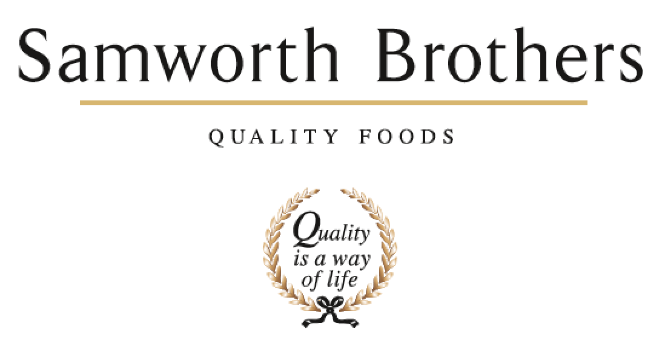

ROLE PROFILE
Job title | Packaging Administrator | Date | Dec 2025
Business | The Cornwall Bakery
Department | Technical
Location | Callington
ROLE SUMMARY
This role is to support the Process Manager and the Packaging Technologists in administration, reporting and record keeping. A keen eye for detail is required and a willingness to learn, also an ability to work to deadlines and manage multiple tasks simultaneously.
REPORTING STRUCTURE
Reports to | Process Manager
Direct & indirect reports | N/A
Key internal stakeholders | Operations Team, Technical Team, NPD Team
Key external stakeholders | All retail and brand customers

KEY ACCOUNTABILITIES AND RESPONSIBILITIES
Key responsibilities/Accountabilities

- Liaise with packaging design companies on all packaging related matters to ensure swiftly resolved and working to correct customer specification.
- Yearly submission details / Supplier 3rd party / Customer related packaging essential requirements.
- Maintenance of product packaging database
- Maintenance of packaging specifications and packaging database, including Supplier Audit status and risk rating.
- Raising Non-conformances with packaging suppliers where appropriate, recording and trending issues, escalating issues when necessary.
- Supporting Packaging techs in producing documentation for internal and external customers.

QUALIFICATIONS, EXPERIENCE, TECHNICAL SKILLS / KNOWLEDGE
- This role requires strong communication skills (written & Verbal) with respect to the content and quality of the communication, as well as delivery method - verbal and written communication form the backbone of this role.
- Good attention to detail.
- Planning and organisational skills.
- Professional approach.
- Calm & measured approach in an often-pressured environment which often involves working to tight deadlines.
- A “can do” attitude and “hands on” approach.
- Ability to approach things pragmatically and consider solutions that deliver on different levels to the business (eg: no detriment to quality, keeping on-cost down, within specification and in time).
- Able to use own initiative to identify and act on business opportunities
- Microsoft literate (particular use of Excel, Word, Outlook and Powerpoint)

CORE COMPETENCIES, ATTRIBUTES & BEHAVIOURS FOR SUCCESS
Competency | Descriptors
Values People | Demonstrates the belief that people are our most important asset and central to the success of the organisation. Everybody should be treated with dignity and respect at all times.
Customer Focus | Demonstrates the understanding that the satisfaction of our internal and external customers is the foundation of our success
Collaborative Team Working | The willingness to act as part of a team and work towards achieving shared objectives through adopting best practice in line with PQP and Federalism.
Flexibility & Adaptability | The ability to change and adapt own behaviour or work procedures when there is a change in the work environment, for example as a result of changing customer needs.
Initiative & taking ownership | Steps up to take on personal responsibility and accountability for tasks and actions in line with PQP and Federalism.
People Management | The ability to understand people and their motivations, build good relationships with them and help them unlock their potential.
Empowering others | Creates an environment where people feel required and enabled to take ownership and responsibility.
Coaching for performance | The ability to help others achieve more through two-way feedback, clear direction and enabling.
Analysis & Planning | The ability to take a range of information, think things through logically and prioritise work to meet commitments aligned with organisational goals.
Drive for Excellence | Knows the most effective and efficient processes for getting things done, with a focus on continuous improvement.

