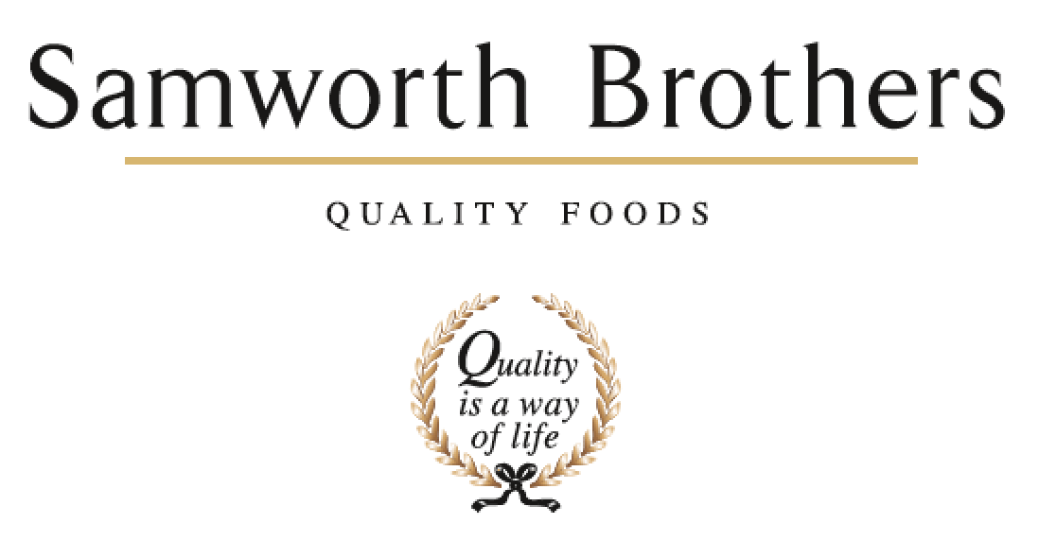

ROLE PROFILE
Job title | QA Team Leader | Date | 11/02/26
Business | Bradgate Bakery – Ashton Green
Department | Technical
Location | Leicester
ROLE SUMMARY
The main purpose of the role is to lead and motivate the QA team in monitoring and evaluating product and processing systems and factory practices to ensure agreed standards of quality are achieved and improved upon and in addition to take a lead in generating and building a quality culture.
REPORTING STRUCTURE
Reports to | QA Manager
Deputy | n/a
Direct & indirect reports | Quality auditors
Key internal stakeholders | Technical  Operations  Process
Key external stakeholders | n/a

KEY ACCOUNTABILITIES AND RESPONSIBILITIES
- To plan and co-ordinate work of the QA team to meet requirements of the quality
management system and the needs of the business ensuring that the QA team are kept up to date with all business and customer communication as appropriate.
- To provide technical support to production and Qa teams.
- To coordinate non-conformance findings including actions taken and report to relevant department managers ensuring completion of any required corrective actions from day-to-day issues e.g. micro results for positive release. In addition, trend non-conformances to identify recurring issues and find and recommend permanent solutions.
- To assist in delivery of site standards for visits and audits either through direct input, indirect support and / or organisation of QA team activities.
- To coordinate QA requirements for product pre-production and launches e.g. update of required documentation / systems, liaison with Process team / line support to ensure product is manufactured to correct standard.
- With guidance from Quality Manager, manage QA activities required to deliver improvement of Technical KPIs e.g. audit of non-conforming processes, complaint investigations, GMP audits, Traceability Audits, Internal Audits.
- To promote a quality culture and help to develop the quality management system.
- Lead, motivate and inspire QA team to achieve personal development and continuous improvement. Complete PDM’s, One to One meetings and support QA team in achieving their personal set targets and goals through agreeing clear objectives.
- To identify Training needs within QA Team and deliver training where and when required.
- To ensure CCP’s and Pre-requisites are regularly audited and challenged by the QA function.
- To operate in a safe working manner and support the site/business on continuous improvement relating to health, safety and the environment.
- To ensure Bakery compliance with BRCGS standards/ Customer code of practice sections

QUALIFICATIONS, EXPERIENCE, TECHNICAL SKILLS / KNOWLEDGE
- Good team working skills
- People management skills.
- Able to coach and train team member
- Ready to eat food industry knowledgesafety
- Haccp / Food safety knowledge and qualifications
- Effective communication skills across all levels
- Experience of managing other people’s expectations
- Organisational/prioritising skills & ability to respond to changes
- Problem solving & decision-making skills
- Ability to negotiate, influence & recognise other viewpoints
- Ability to develop effective relationships with other areas across the site
- Working knowledge of computer systems, use of excel

CORE COMPETENCIES, ATTRIBUTES & BEHAVIOURS FOR SUCCESS
Competency | Descriptors
Values People | Demonstrates the belief that people are our most important asset and central to the success of the organisation. Everybody should be treated with dignity and respect at all times.
Customer Focus | Demonstrates the understanding that the satisfaction of our internal and external customers is the foundation of our success
Collaborative Team Working | The willingness to act as part of a team and work towards achieving shared objectives through adopting best practice in line with PQP and Federalism.
Flexibility & Adaptability | The ability to change and adapt own behaviour or work procedures when there is a change in the work environment, for example as a result of changing customer needs.
Initiative & taking ownership | Steps up to take on personal responsibility and accountability for tasks and actions in line with PQP and Federalism.
Drive for Excellence | Knows the most effective and efficient processes for getting things done, with a focus on continuous improvement.
Resource Management | Effectively manages resources and cost drivers to achieve sustainable productivity and profitability.
Technical Expertise | Has the skills, knowledge and experience required to excel in own area of specialism and the willingness to further grow and develop.
Self-Management | Uses a combination of feedback and reflection to gain insight into personal strengths and weaknesses, so that own time, priorities and resources can be managed to achieve goals.

