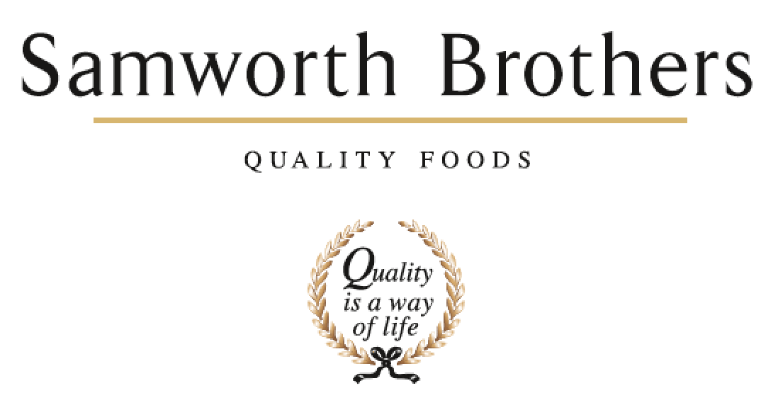

ROLE PROFILE
Job title | Multi Skilled Engineer | Date
Business
Department | Engineering
Location
ROLE SUMMARY
This role will be responsible for fault finding, repairs, planned preventative maintenance and continuous improvement across the food production site.

REPORTING STRUCTURE
Reports to | Team Leader
Direct & indirect reports | N/A
Key internal stakeholders | Production
Key external stakeholders | N/A

KEY ACCOUNTABILITIES AND RESPONSIBILITIES
- To carry out day to day repair and maintenance of all equipment on site.
- To liaise with production to provide proactive support to ensure efficiency of production runs.
- To carry out all reporting and documentation as required by the engineering department.
- To be proactive in finding permanent solutions to engineering problems.
- To comply with and strongly advocate all relevant Health and Safety, Food Hygiene, Environmental Legislation, and Statutory Legislation for self, contractors and others, whilst carrying out engineering activities.

QUALIFICATIONS, EXPERIENCE, TECHNICAL SKILLS / KNOWLEDGE
- Good organisational skills
- Must be a team player
- Ability to work on own initiative in a responsible manner
- Ability to work under pressure
- Good communicator and have the ability to develop strong relationships with members of staff from all departments
- Must have a hands-on approach to problem solving
- Must have strong documentation skills when detailing actions taken.
- Must have a flexible approach to working patterns and overtime working
- Must have a good working knowledge of electrical control systems, inverter drives, and pneumatic systems
- Electrically qualified to level 3 or greater
- Minimum of 2 years experience ideally within Manufacturing

CORE COMPETENCIES, ATTRIBUTES & BEHAVIOURS FOR SUCCESS
Competency | Descriptors
Values People | Demonstrates the belief that people are our most important asset and central to the success of the organisation. Everybody should be treated with dignity and respect at all times.
Customer Focus | Demonstrates the understanding that the satisfaction of our internal and external customers is the foundation of our success
Collaborative Team Working | The willingness to act as part of a team and work towards achieving shared objectives through adopting best practice in line with PQP and Federalism.
Flexibility & Adaptability | The ability to change and adapt own behaviour or work procedures when there is a change in the work environment, for example as a result of changing customer needs.
Initiative & taking ownership | Steps up to take on personal responsibility and accountability for tasks and actions in line with PQP and Federalism.
Drive for Excellence | Knows the most effective and efficient processes for getting things done, with a focus on continuous improvement.
Resource Management | Effectively manages resources and cost drivers to achieve sustainable productivity and profitability.
Technical Expertise | Has the skills, knowledge and experience required to excel in own area of specialism and the willingness to further grow and develop.
Self-Management | Uses a combination of feedback and reflection to gain insight into personal strengths and weaknesses, so that own time, priorities and resources can be managed to achieve goals.

