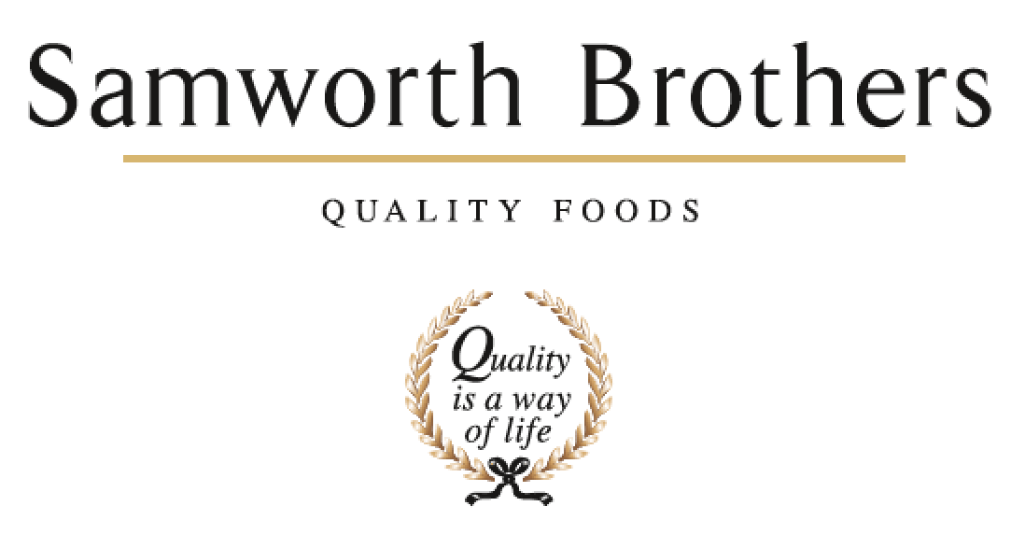

ROLE PROFILE
Job title | Product Developer | Date | 19th Feb 2026
Department | Marketing
Location | Soreen
ROLE SUMMARY
Summarise in one or two sentences the highlights of the job in terms of its purpose and overall responsibility.
Take research & insight and develop and refine products to meet customer needs, business goals and regulatory standards. Creating recipes for innovation, EPD or H & S Diets opportunities. Trialling and validating product through the NPD Process to ensure a smooth transition from NPD To live in market.

REPORTING STRUCTURE
Reports to | Innovation Lead
Key internal stakeholders | Process Technologist / Technical Team / Ops Team
Key external stakeholders | Group Procurement

KEY ACCOUNTABILITIES AND RESPONSIBILITIES
Soreen NPD launches
- Lead and manage food development aspects of NPD to ensure delivery on time and within budgets.
NPD Pipeline
- Commence work on further out projects in innovation pipeline to ensure on track for launch
- Work closely with Innovation Lead and marketing team to continually improve long term NPD pipeline.
Renovation
- Lead food development initiatives coming from the H & S Diets Forum
NPD Process
- Working in partnership with Innovation Lead & NPD Project Executive, optimise NPD process
Supplier relationships & cost improvement PIPS
- Build relationships with Suppliers & Group Procurement
- Review opportunities for improvement (cost savings / reduced complexity)
Internal NPD profile
- Champion the NPD short / mid / long term innovation plan
NPD budget control
- Control and manage the Soreen R&D budget.
- Complaint Reduction - support the Technical & Operations team in achieving their targets for complaints reduction
Support Sales team:
- Support Sales team in selling in NPD via timely production of Sales samples to high quality and in usable way (e.g. clearly labelled, delivered on-time).

QUALIFICATIONS, EXPERIENCE, TECHNICAL SKILLS / KNOWLEDGE
List the skills gained through education and experience required to effectively function in the position
- Educated to degree level
- Strong food development background – recipe development, test baking etc
- Strong interpersonal skills with excellent written and verbal communication
- Commercially astute with good analytical skills
- The ability to work on multiples tasks under pressure and to deadlines
- Good attention to detail and accuracy
- The ability to work collaboratively as part of a team with people from all functions within the business as well as people externally (from our agencies)
- Flexibility to adapt to changing business needs given evolutionary and attrition in an innovation role.
- Good organisation and planning skills
- An ability to manage suppliers: to motivate them and get the best out of them, but also to be firm when results are not being achieved
ATTRIBUTES & BEHAVIOURS FOR SUCCESS
Behaviour | Descriptors
Focused on developing people | - Consistently demonstrates that people are the top business priority.  - Devotes a significant % of time to supporting and coaching their people.  - People related activities are consistently placed high on the “to do” list.  - Always make themselves available to support team members, regardless of how busy they are.
Builds strong relationships | - Demonstrates they are a good listener who can take on board other points of view.  - Demonstrates trust in other teams and other colleagues.  - Displays a high level of emotional intelligence to understand how to improve a relationship.  - Willing to be the “better person” for the sake of building or maintaining a relationship.  - Consciously aware of key relationships which require more work to improve.
Courage to make tough decisions | - Demonstrates they can make a positive decision when none of the alternatives are attractive.  - Is able to make quick decisions when needed even if the data is not complete.  - Is able to take the “hard / right” decision (which will upset some people) rather than always opting for the “easy / but wrong” decisions.  - Consistently demonstrates high standards and does not drop standards just because the implications are challenging.
Calmness during challenging times | - The more challenging the situation the calmer we want our people to be.  - Does not get over-emotional when things go wrong.  - Recognises that challenging times call for the best kind of leadership.  - Focuses on the issue…….not the person who made a mistake or who discovered a problem.
Leads by example | - We should “walk the walk” as well as “talk the talk”.  - Displays a consistent approach in how they deal with everyone in the business regardless of their level.  - Demonstrates an unshakeable positive attitude regardless of how challenging the circumstances.  - Appreciates the views of everyone in the business and welcomes new ideas and challenges.

