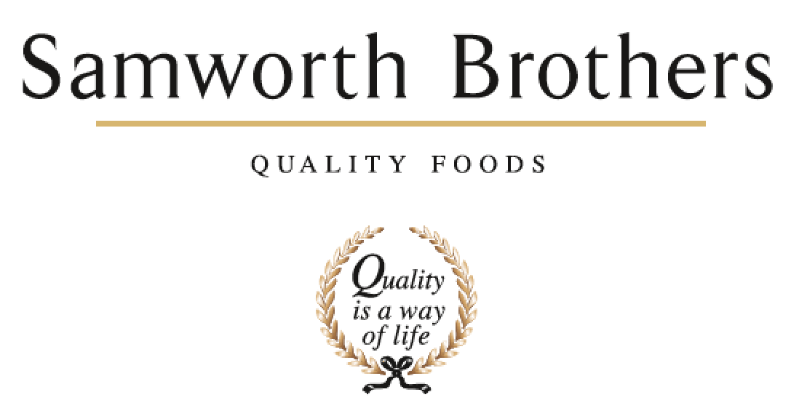

ROLE PROFILE
Job title | Packaging Technologist | Date | Feb 2026
Business | Meals Division
Department | Development
Location | Melton Mowbray & Leicester
ROLE SUMMARY
An exciting opportunity for an enthusiastic and motivated person to join our growing Packaging Team. Working within the Development function the successful candidate will work to oversee Packaging across the two Samworth Brothers Meals sites located within Leicestershire in a diverse role. The successful candidate will play a key role in creating new and enhancing existing packaging solutions that support our business growth. This is a brilliant opportunity for someone with a passion for packaging, strong multitasking abilities and the drive to deliver meaningful change.

REPORTING STRUCTURE
Reports to | Packaging Manager
Direct & indirect reports | Development Managers, Development Technologists
Key internal stakeholders | Development, Technical Services, Operations, Commercial, Process, Planning, Engineering, Supply Chain, Procurement
Key external stakeholders | All external customers and suppliers

KEY ACCOUNTABILITIES AND RESPONSIBILITIES
- Partner with cross-functional teams to deliver packaging solutions for all NPD and EPD projects – ensuring innovation is built into the process from the start, solutions are consumer focussed and commercially viable.
- You will be a key member of the packaging team regarded as the “go-to” technical packaging expert, utilising your technical expertise to both lead and support project teams on all technical packaging aspects.
- Represent packaging across the Meals category, building relationships with key site and project stakeholders.
- Drive continuous improvement, making recommendations that enhance sustainability, consumer experience and operational performance.
- Partner with the Packaging Manager to validate packaging performance through trials, testing, and production runs.
- Attend exhibitions and webinars to identify trends and potential business opportunities.
- Manage packaging timelines and deliverables within the full NPD project plan to ensure on-time, in-full launches.
- Champion sustainability by identifying improvements in recyclability, material efficiency, and waste reduction.
- Work closely with the Packaging Buyers to ensure packaging choices meet cost, commercial, and availability criteria.
- Create mock-ups and source samples to support customer presentations.
- Oversee artwork approvals from a packaging perspective.

QUALIFICATIONS, EXPERIENCE, TECHNICAL SKILLS / KNOWLEDGE
Qualifications
- Degree Qualification is desirable.
- Any packaging focussed courses would also be a benefit.

Experience & Skills
- Experience of working with a FMCG environment ideal but not essential.
- Effective communication skills
- Focussed on achieving results
- A self-starter able to use own initiative with a pro-active approach
- Problem solving & organisation skills
- Ability to work well under pressure
- Computer Literacy (Word, Excel, PowerPoint, databases, Internal systems)
- Driving License is required

CORE COMPETENCIES, ATTRIBUTES & BEHAVIOURS FOR SUCCESS
Competency | Descriptors
Values People | Demonstrates the belief that people are our most important asset and central to the success of the organisation. Everybody should be treated with dignity and respect at all times.
Customer Focus | Demonstrates the understanding that the satisfaction of our internal and external customers is the foundation of our success
Collaborative Team Working | The willingness to act as part of a team and work towards achieving shared objectives through adopting best practice in line with PQP and Federalism.
Flexibility & Adaptability | The ability to change and adapt own behaviour or work procedures when there is a change in the work environment, for example as a result of changing customer needs.
Initiative & taking ownership | Steps up to take on personal responsibility and accountability for tasks and actions in line with PQP and Federalism.
Drive for Excellence | Knows the most effective and efficient processes for getting things done, with a focus on continuous improvement.
Resource Management | Effectively manages resources and cost drivers to achieve sustainable productivity and profitability.
Technical Expertise | Has the skills, knowledge and experience required to excel in own area of specialism and the willingness to further grow and develop.
Self-Management | Uses a combination of feedback and reflection to gain insight into personal strengths and weaknesses, so that own time, priorities and resources can be managed to achieve goals.

