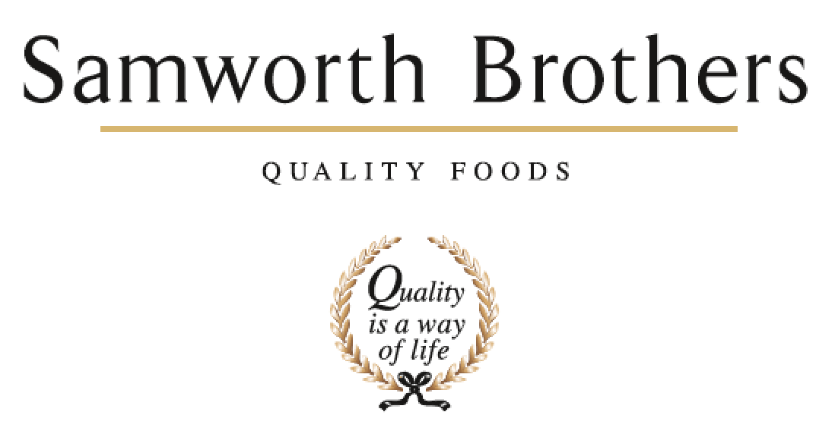

ROLE PROFILE
Job title | Social Media Manager | Date | April 20626
Business | Ginsters
Department | Marketing
Location | Plymouth, with hybrid working arrangements and some travel to The Cornwall Bakery (Callington) and London
ROLE SUMMARY
We have big ambitions for the Ginsters brand and are looking for a dynamic and creative Social Media Manager to join our team to continue optimising our approach to engage with our consumers, creating fame driving and culturally relevant social media activations.
Reporting to Ginsters Marketing Manager, this role will be responsible for leading the creation of world class content on our suite of social channels. You'll manage the Ginsters personality and tone of voice inline with brand guidelines to bring the brand to life across social platforms, engaging with consumers in relevant topics and conversations ensuring Ginsters is present and visible.
Working closely with the Marketing Manager, Agencies and Brand Managers to define Ginsters social media strategy and responsible for executing the strategy via content creation, community management and reporting.
Day to day you will be responsible for Ginsters community management, responding to customer care contacts via all social channels. You will also co-create reactive and organic content, telling the stories of the brand and identifying opportunities to drive brand fame and cultural relevance through ongoing conversations.
The successful candidate will be commercially aware with strong analytical skills that support their creativity. You will be expert at managing and monitoring performance of owned and earned content and proactively analyse and report on competitor activity. The successful candidate will also be responsible for setting clear benchmarks and KPIs for the brand in the social media space, setting the standards and upholding them.

REPORTING STRUCTURE
Reports to | Ginsters Marketing Manager
Direct & indirect reports | No direct reports  Requirement to influence across the organisation
Key internal stakeholders | Marketing team  Insights Team  Innovation Team  Cornwall Bakery  Sales team
Key external stakeholders | PR & Social Media agencies  Consumer Careline agency  Creative & Media agencies  Insight agencies

KEY ACCOUNTABILITIES AND RESPONSIBILITIES
Contribute to the sustainable long-term growth of the Ginsters brand by building and growing an engaged online community base for Ginsters. Make the brand part of cultural conversations to drive relevance & fame by delivering ongoing brilliant conversation and customer service.

- Work with our lead social agency & Marketing Manager to define and execute Ginsters Social Media Strategy to achieve the brand’s long term and short-term ambitions
- Align to the overall Ginsters strategy, understanding commercial and audience priorities, using data and insights to challenge the status quo and consistently influence content, channel and audience development through insights and ideas
- Work with key partners across Ginsters Marketing, Consumer Services and Agency Team to identify and feed into campaign and real-time content opportunities
- Responsible for planning our content calendar across Meta, TikTok & LinkedIn and any other relevant platforms working alongside agency partners and brand managers to align to brand priorities. Including creation of original social media copy and publish compelling content in alignment with Ginsters brand standards and tone of voice
  - Create own assets using relevant mediums (e.g. video, GIFs, still imagery & graphics or copy)
  - Brief and manage external agencies and content creators to deliver high quality campaign content when required and where relevant
  - Working with the wider team, develop and execute ideas for exciting still image and video shoots across a range of business areas.

- Deliver day to day community management across platforms, ensuring all engagement is conducted in a timely fashion with the appropriate tone of voice.
- Identify and engage in real-time with consumers, brands, influencers and celebrities that are talking about the brand, or relevant conversations to the brand, across social media channels – be part of the conversation and be reactive to content creation to ensure we are timely and relevant to trends.
- Take the lead on our community reward programme ‘Pastry Club’ identifying brand fans and building on our community to share with them insider news on the brand and new product launches.
- Contribute to the annual brand and budget planning process, identifying how social can support and amplify our brand priorities, responsible for managing in -year budget and phasing.
- Manage multiple internal stakeholders (marketing/sales/innovation/PR etc.) and external partners (agencies/partners/media etc.) to deliver end-to-end projects and campaigns as defined in the annual brand plans – on time and in budget, within a clear approval process
- Lead on planning and briefing media agency on paid amplification of organic content as agreed with Ginsters Marketing Manager
- Executes our influencer/ content creator strategy, including identifying creators, outreach, briefing, feedback and managing on-going relationships.
- Proactively keep abreast of social media trends and platform developments, remaining agile to adaptations to plans and approaches.
- Utilising social listening tool Sprout, on a daily basis to monitor brand sentiment, including feedback and engagement
- Consistently monitor and analyse the performance of ad hoc and planned communications within social media. Use insights to inform ongoing strategy and tactics for social media, including;
  - Setting clear KPI’s across (paid, organic and influencer content)
  - Regular reporting on social media content and channel performance to internal stakeholders
  - Analyse and report on competitor activity across social media on a monthly basis
  - Updating the cross-functional team in monthly forums and bi-annual brand sell engagements.

QUALIFICATIONS, EXPERIENCE, TECHNICAL SKILLS / KNOWLEDGE
- 3-5 years experience in a similar role delivering social media marketing within a Marketing team or Marketing agency environment
- Knowledge of best practice across all key social media platforms, including Facebook, X, Instagram, TikTok, Pinterest, Reddit, Youtube & LinkedIn
- Passion for creating compelling social media content
- Strong copywriting and editing skills suitable for each platform
- Ability to create own content, graphic design / videography skills
- Experience of handling consumer feedback and complaints.
- Experience of content and strategy planning
- Reporting and analysis skills
- Experience of managing or working with creative agencies and the ability to create clear and compelling briefs
- Organised and efficient with the ability to react quickly and accurately to opportunities and work to tight deadlines
- Previous experience of working in an office environment, and skilled across Microsoft Office packages
- Strong communicator with the ability to engage internal stakeholders at all levels and excite our external partners
- Experience within an FMCG environment, ideally with a food brand, is preferred but not essential.

CORE COMPETENCIES, ATTRIBUTES & BEHAVIOURS FOR SUCCESS
Competency | Descriptors
Values People | Demonstrates the belief that people are our most important asset and central to the success of the organisation. Everybody should be treated with dignity and respect at all times.
Collaborative Team Working | The willingness to act as part of a team and work towards achieving shared objectives through adopting best practice in line with our purpose statement and Company values.
Flexibility & Adaptability | The ability to change and adapt your behaviour or work procedures when there is a change in the work environment, for example as a result of changing customer needs.
Initiative & taking ownership | Steps up to take personal responsibility and accountability for tasks in line with our purpose statement and our Company values.
Decision making and judgement | In line with our new purpose statement and Company values, makes timely and informed decisions that take into account the facts, goals, constraints and risks that keep the organisation moving forward.
Commercial awareness | Demonstrates an understanding of the impact decisions and actions have on the organisation in line with our new purpose statement and Company values.
Developing partnerships | The ability to establish formal and informal relationships inside and outside the organisation, and to anticipate and balance the needs of those whose cooperation is needed for the long-term success of the business.
Understanding consumers to discover insights | Being passionate and curious about consumers - developing with Group Insights a deep intimacy with consumers & shoppers, as brand users/shoppers/citizens, using research and social media. Building a picture of how they live, work, shop, consume media etc
Creating Briefs & briefing Creative Agencies | Ensuring precision in a brief: Showing a clear link from insight to concept to the main point that will drive the desired consumer response.  Deliver inspiring briefs to creative agencies that excite and engage them whilst holding everyone accountable for delivering the business task.
Producing communication assets | Development and crafting of ideas through to the finished film/asset paying close attention to research findings, copy development, casting etc. Producing physical communication assets and selecting and using the right production partners in the most cost-effective way.  Understanding and leveraging Distinctive Brand Assets and how to use them effectively in creative

