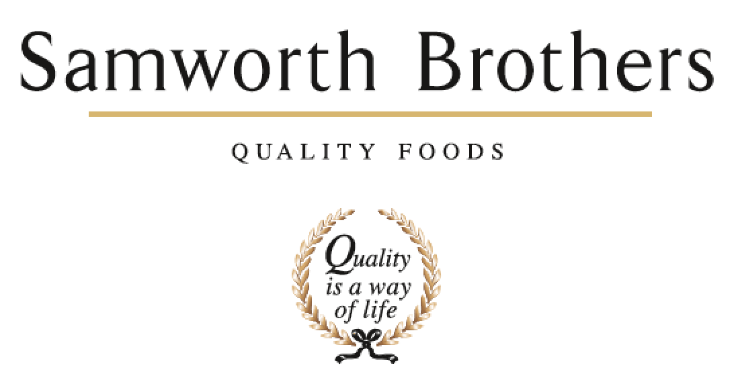

ROLE PROFILE
Job title | Class C + E Driver | Date | August 2016
Business | Samworth Brothers Supply Chain
Department | Transport
Location | Bristol
ROLE SUMMARY
To ensure the on time delivery of goods into depots across the UK
REPORTING STRUCTURE
Reports to | Operations Shift / Support Manager

KEY ACCOUNTABILITIES AND RESPONSIBILITIES
- Responsibility for your own health and safety and that of others who may be affected by your acts or omissions at work. General responsibilities include, but are not limited to:

- Attending training and undergoing such assessment as may be necessary

- Reporting accidents and incidents to their manager

- In line with the BRC standard, to comply with the management systems in place to ensure food safety and quality standards are met and maintained at all times.

- Represent the company in a professional manner at all times

- Ensuring on time deliveries into depots

- Collecting stock from third party suppliers to return to depot

- Checking the vehicle is in a road worthy condition and to report any defects

- Checking the correct trailer is picked up and ensuring that the load is secure

- Ensuring the correct paperwork and PODs are collated and returned

- Helping to break down loads at depots

- Ensuring to work within the parameters of the law at all times

- Adhering to Health and Safety procedures at all times

QUALIFICATIONS, EXPERIENCE, TECHNICAL SKILLS / KNOWLEDGE
- Good interpersonal skills
- Teamwork
- Good analytical skills
- Continuous Improvement Focus
- Health and Safety Focus

CORE COMPETENCIES, ATTRIBUTES & BEHAVIOURS FOR SUCCESS
Competency | Descriptors
Values People | Demonstrates the belief that people are our most important asset and central to the success of the organisation. Everybody should be treated with dignity and respect at all times.
Customer Focus | Demonstrates the understanding that the satisfaction of our internal and external customers is the foundation of our success
Collaborative Team Working | The willingness to act as part of a team and work towards achieving shared objectives through adopting best practice in line with PQP and Federalism.
Flexibility & Adaptability | The ability to change and adapt own behaviour or work procedures when there is a change in the work environment, for example as a result of changing customer needs.
Initiative & taking ownership | Steps up to take on personal responsibility and accountability for tasks and actions in line with PQP and Federalism.

