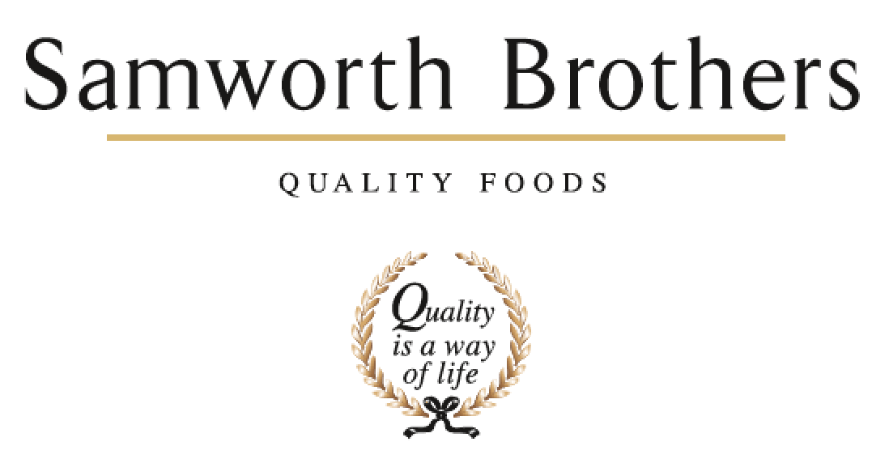

ROLE PROFILE
Job title | Automation Delivery Manager | Date | 16/12/2025
Business
Department | FTG Project Manager Office
Location | Leicester
ROLE SUMMARY
The Automation Delivery Manager is responsible for leading the delivery of automation initiatives across Food-to-Go factories, from concept through implementation and handover. The role ensures automation projects are implemented safely on time and within budget; while achieving clear productivity, labour reduction and capacity outcomes aligned to the 5-year Automation & Digitalisation Strategy.
This role acts as the bridge between strategy and execution, translating automation roadmaps into scalable, repeatable solutions, managing suppliers and internal stakeholders, and ensuring projects deliver measurable ROI and sustainable operational benefits.
REPORTING STRUCTURE
Reports to | Automation Project Manager
Direct & indirect reports | Automation Project Engineers
Key internal stakeholders | Strategic Projects Director, Transformation Director, Site Directors, Engineering Managers, Operations Managers, SHE Managers, CI Managers
Key external stakeholders | N/A

KEY ACCOUNTABILITIES AND RESPONSIBILITIES
Automation Strategy & Portfolio Delivery
- Lead delivery of automation projects aligned to the FTG Automation & Digitalisation Strategy.
- Translate strategic objectives into executable project portfolios across multiple factories.
- Ensure projects deliver clear business outcomes (labour reduction, capacity, quality, ROI).
New Technology, R&D & Innovation Delivery
- Lead R&D, proof-of-concept (PoC), and pilot automation projects for emerging technologies.
- Assess and progress solutions through Technology Readiness Levels (TRL) and Manufacturing Readiness Levels (MRL).
- Decide when technologies are ready to scale from pilot to full production deployment.
- Partner with universities, research centres, OEMs, and innovation bodies on applied automation projects.
Project Execution & Governance
- Own end-to-end delivery: concept, feasibility, URS, supplier selection, FAT, SAT, commissioning, and handover.
- Manage budgets, timelines, risks, and dependencies across multiple concurrent projects.
- Ensure consistent project governance, reporting, and stakeholder communication.
Systems & Integration Leadership
- Ensure automation solutions integrate effectively with upstream/downstream equipment and digital systems.
- Collaborate with OT/IT teams to align automation projects with site and group architectures.
- Support standardisation of automation platforms, specifications, and design principles.
Team Leadership & Capability Building
- Line-manage Automation Project Engineers and support their technical and professional development.
- Provide technical direction, design challenge, and decision support to junior engineers.
- Embed best practice in automation delivery, safety, and project execution.
Supplier & Partner Management
- Lead engagement with system integrators, equipment suppliers, and technology partners.
- Challenge supplier solutions to ensure performance, scalability, and value for money.
- Capture lessons learned and feed them into future standards and designs.
Financial & Business Accountability
- Own automation project business cases, including capex, benefits, payback, and risk.
- Ensure automation investments achieve agreed ROI and operational performance targets.
- Support prioritisation of projects based on opportunity vs feasibility and readiness.
Safety, Quality & Compliance
- Ensure all automation projects comply with machinery safety, food safety, and regulatory standards.
- Promote safe-by-design principles from concept through commissioning.

QUALIFICATIONS, EXPERIENCE, TECHNICAL SKILLS / KNOWLEDGE
Qualifications
- Degree in Engineering, Automation, Robotics, Mechatronics, Manufacturing Systems, or a related discipline.
- Project management qualification (e.g. PRINCE2, PMP, Agile) desirable.
- Machinery safety training desirable.
- Exposure to research-led or innovation programmes (e.g. pilots, Proof-of-Concepts (PoC), R&D demonstrators, funded projects) advantageous.

Experience
- 5–7+ years’ experience delivering industrial automation and digital manufacturing projects within manufacturing environments and/or applied research institutions (e.g. universities, research and innovation centres, etc.).
- Proven track record of leading automation projects from concept and feasibility through PoC, pilot, scale-up, and full production deployment.
- Experience delivering new and emerging technologies, including managing Technology Readiness Level (TRL) and Manufacturing Readiness Level (MRL) progression.
- Strong experience working with system integrators, OEMs, robotics suppliers, and technology partners.
- Exposure to food, FMCG, or high-volume manufacturing environments preferred.
- Experience managing and mentoring junior engineers and cross-functional project teams.

Technical Skills / Knowledge
- Industrial automation solutions including robotic cells (6-axis, SCARA, delta, cobots, humanoid robots, etc.), conveyors, packing, palletising, and material handling systems.
- Hands-on knowledge of PLCs, robot controllers, vision systems, safety systems, and emerging technologies (AI/ML-enabled automation, advanced robotics, humanoid robots, etc.).
- Strong understanding of the full automation project lifecycle: concept, feasibility, URS, Proof-of-Concepts (PoC), FAT, SAT, commissioning, handover, and stabilisation.
- Experience leading R&D projects and proof-of-concept implementations, with a focus on de-risking, scalability, and industrialisation.
- Understanding of OT/IT integration principles, industrial communication protocols, and digital manufacturing architectures.
- Strong financial and delivery awareness: CAPEX planning, ROI, payback periods, delivery risk, and benefits realisation.
CORE COMPETENCIES, ATTRIBUTES & BEHAVIOURS FOR SUCCESS
Competency | Descriptors
Values People | Demonstrates the belief that people are our most important asset and central to the success of the organisation. Everybody should be treated with dignity and respect at all times.
Customer Focus | Demonstrates the understanding that the satisfaction of our internal and external customers is the foundation of our success
Collaborative Team Working | The willingness to act as part of a team and work towards achieving shared objectives through adopting best practice in line with PQP and Federalism.
Flexibility & Adaptability | The ability to change and adapt own behaviour or work procedures when there is a change in the work environment, for example as a result of changing customer needs.
Initiative & taking ownership | Steps up to take on personal responsibility and accountability for tasks and actions in line with PQP and Federalism.
Drive for Excellence | Knows the most effective and efficient processes for getting things done, with a focus on continuous improvement.
Resource Management | Effectively manages resources and cost drivers to achieve sustainable productivity and profitability.
Technical Expertise | Has the skills, knowledge and experience required to excel in own area of specialism and the willingness to further grow and develop.
Self-Management | Uses a combination of feedback and reflection to gain insight into personal strengths and weaknesses, so that own time, priorities and resources can be managed to achieve goals.

