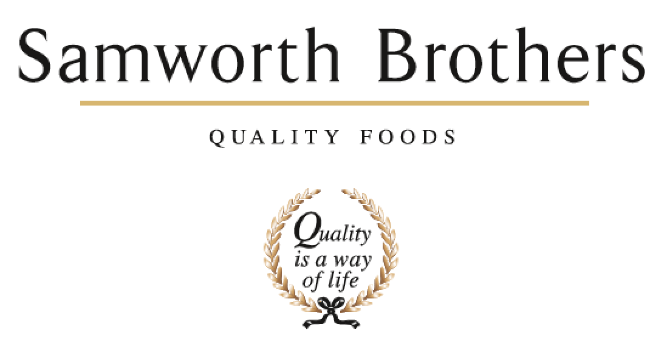

ROLE PROFILE
Job title | QA Supervisor | Date | Feb-26
Business | Walker & Son (Including Abbey Bakery)
Department | Technical
Location | 200 Madeline Road & 60 Cobden St, Leicester
ROLE SUMMARY
The Quality Assurance Supervisor is responsible for ensuring the safe, legal, authentic and compliant manufacture of all products produced at Walker & Son, Abbey Bakeries. The role provides visible, shift-based technical leadership across the whole operation

The QA Supervisor ensures full implementation of HACCP controls, retailer codes of practice and Samworth Brothers standards while supporting operational performance and continuous improvement.

As part of a team you will need to have really good communication skills, not only verbal but also written ones; of course you’ll still spend a lot of time working on your own initiative, particularly when covering shift production.

You’ll need to have a resilient type of personality because occasionally you may be required to make unpopular decisions with which others disagree.

The job is one which requires a high level of personal organisational and time management skills to make sure all of the work is done and recorded properly.
REPORTING STRUCTURE
Reports to | QA Manager
Direct & indirect reports | QA Team, QA Manager, Technical Manager
Key internal stakeholders | Technical, Planning, Operations, NPD, Engineering
Key external stakeholders | Retail Customers, Third Party Auditors

KEY ACCOUNTABILITIES AND RESPONSIBILITIES
Food Safety & CCP Control
- Build and verify daily CCP, allergen and temperature verification plans.
- Ensure 100% CCP verification completion and real-time deviation escalation.
- Review CCP and metal detection trends weekly.
Calibration & Equipment Integrity
- Maintain calibration systems for probes, metal detection and coding equipment.
- Ensure no overdue critical equipment.
- Verify belt and tooling integrity to prevent foreign body risk.

GMP, Hygiene & Site Standards
- Issue GMP, Glass & Hard Plastic and Pest control rotas.
- Trend GMP and hygiene non-conformances monthly.
- Support Environmental Monitoring Programme and validation activities.
Holds, Release & Traceability
- Oversee product hold, release and destruction processes.
- Ensure full audit trail and traceability compliance.
Labelling & Customer Compliance
- Verify artwork, coding and packaging compliance.
- Maintain compliance with retailer-specific requirements.
- Investigations & NCR Management
- Lead investigations into complaints, microbiological failures and incidents.
- Close Minor NCRs within SLA and lead Major/Critical investigations.
People Leadership & Culture
- Coach and mentor QA Technicians.
- Maintain skills matrices and competency sign-off.
- Promote right-first-time quality culture.
- Support the business with Projects and CI

QUALIFICATIONS, EXPERIENCE, TECHNICAL SKILLS / KNOWLEDGE
- Experience within chilled food / FMCG manufacturing.
- HACCP Level 3.
- Level 3 Food Hygiene (minimum).
- Understanding of Environmental Monitoring and Listeria control.
- Strong data interpretation and communication skills.
- Good communication skills (including telephone), Eye for detail & Ability to challenge
- Strong team player and leader with the ability to work across multiple functions and disciplines.
- Must be able to effectively communicate ideas (verbally and in writing), be a self-starter and handle difficult reporting situations.
- Must have a knowledge of Microsoft applications e.g. Excel, Word, Powerpoint.
- Must have a understanding of Web-based systems e.g. Microsoft Edge and Google Chrome

CORE COMPETENCIES, ATTRIBUTES & BEHAVIOURS FOR SUCCESS
Competency | Descriptors
Values People | Demonstrates the belief that people are our most important asset and central to the success of the organisation. Everybody should be treated with dignity & respect at all times.
Customer Focus | Demonstrates the understanding that the satisfaction of our internal customers and external customers/ consumers is the foundation of our success.
Collaborative Team Working | The willingness to act as part of a team and work towards achieving shared objectives through adopting best practice in line with PQP and Federalism.
Flexibility & Adaptability | The ability to change and adapt your behaviour or work procedures when there is a change in the work environment, for example as a result of changing customer or business needs.
Initiative & Taking Ownership | Steps up to take personal responsibility and accountability for tasks in line with PQP and Federalism.

