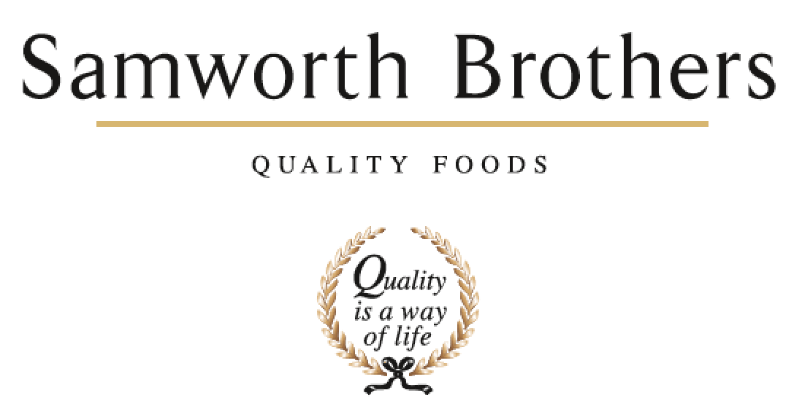

ROLE PROFILE
Job title | Development Chef | Date | 23/1/26
Business | Savoury Pastry
Department | Development and Innovation
Location | The Cornwall Bakery
ROLE SUMMARY
To work within the NPD Team to deliver high quality concepts, products, recipes, and to ensure delivery of all projects in a timely manner ensuring concept to launch process is followed. Interpret & Pre-empt customer briefs to ensure new and relevant products are being proposed to our customers and brands. To support the customer engagement days to grow The Cornwall Bakery Business. Maintain up to date and relevant knowledge of products & equipment within the market and capturing trends and quality improvements to enable Samworth Brothers savoury pastry to stay ahead of the competition.

REPORTING STRUCTURE
Reports to | Senior Development manager
Direct & indirect reports | None
Key internal stakeholders | NPD team, Process team, Technical, Operations, Category & Commercial
Key external stakeholders | Customers & Suppliers

KEY ACCOUNTABILITIES AND RESPONSIBILITIES
- Manage and Strengthen customer accounts, leading NPD and EPD in line with strategic direction along with proactively seeking new opportunities to grow accounts.
- Work with cross functional teams to understand and evaluate relevant insights, market opportunities and consumer understanding.
- Support the business with the investment projects required for the Cornwall bakery relevant to the development function.
- Challenge and drive processes within the bakery and development teams in order to support an ongoing culture of quality.
- Assist in generating and delivering the innovation and blue-sky pipeline with the innovation and development teams within Savoury pastry.
  - Develop market leading NPD demonstrating creativity and flavour which will WOW our customers.
- Ensure an up-to-date knowledge and understanding of current food trends and influences utilising and showing an understanding in all development projects.
- Use the Recipe Professor system and ensure the information you input is accurate correct.
- Ensure feasibility meetings are conducted for all development projects.
- Organisation and preparation of food samples, to include ordering of materials, costing, practical application, and despatch of product.
- Assist & lead product presentations both internally and externally.
- Understand the customer brand values to enable effective translation into product
proposition.
- Understand the business current and future capabilities to develop outstanding products that translate effectively once scaled up.
- Handover products supporting the operations & technical teams with product launches.
- To assist in building a positive food culture – challenging the operations and process functions to improve product quality and enhance the business reputation as development experts.
- Communicate, collaboratively and build network with the wider Samworth Brothers innovation and development teams.
Please note this job list is not exhaustive and may include other duties deemed to be within the share of responsibilities.

QUALIFICATIONS, EXPERIENCE, TECHNICAL SKILLS / KNOWLEDGE
- Experience as a chef, or product technologist ideally within chilled food manufacturing
- Be able to demonstrate natural flair and passion for food and knowledge of a variety of cuisines.
- Be able to demonstrate practical cooking demonstrations to a high level.
- Demonstrate a natural ability to be creative and innovative in terms of recipes, marketing ideas and packaging solutions.
- Consumer and customer focus with ability to link trends to consumer and occasion.
- Be able to present new products and improvements of existing products.
- Computer literate with a working knowledge of Microsoft Excel, PowerPoint, and Word.
- Full Driving Licence required.
- Proactive team player, able to perform under pressure and within tight timeframes.
- Have a flexible approach to work and working hours, to meet the needs of the business.

CORE COMPETENCIES, ATTRIBUTES & BEHAVIOURS FOR SUCCESS
Competency | Descriptors
Values People | Demonstrates the belief that people are our most important asset and central to the success of the organisation. Everybody should be treated with dignity and respect at all times.
Customer Focus | Is passionate about quality, striving to continuously make a positive difference for our customers and our consumers.
Collaborative Team Working | The willingness to act as part of a team and work towards achieving shared objectives through adopting best practice in line with our purpose statement and Company values.
Flexibility & Adaptability | The ability to change and adapt your behaviour or work procedures when there is a change in the work environment, for example as a result of changing customer needs.
Initiative & taking ownership | Steps up to take personal responsibility and accountability for tasks in line with our purpose statement and our Company values.
Drive for Excellence | Knows the most effective and efficient processes for getting things done, with a focus on continuous improvement.
Resource Management | Effectively manages resources and cost drivers to achieve sustainable productivity and profitability.
Technical Expertise | Has the skills, knowledge and experience required to excel in own area of specialism and the willingness to further grow and develop.
Self-Management | Uses a combination of feedback and reflection to gain insight into personal strengths and weaknesses, so that own time, priorities and resources can be managed to achieve goals.

