- Role Description

Job Title: | Site Service Manager
Location: | Saladworks
Division: | Meal Division

Role Definition: (Summarise the purpose of the role and the contribution this job makes to the organisation’s purpose – what is it here to deliver).
To efficiently manage the engineering functions of the site and to play an active role in supporting the business ensuring Health and safety is at the forefront of systems and decisions.
People Responsibility (structure below)
Deliver engineering KPI’s to improve performance and overall site efficiencies.

Reporting Relationships: (Insert an organisational chart showing where this job sits and the jobs immediately around it).
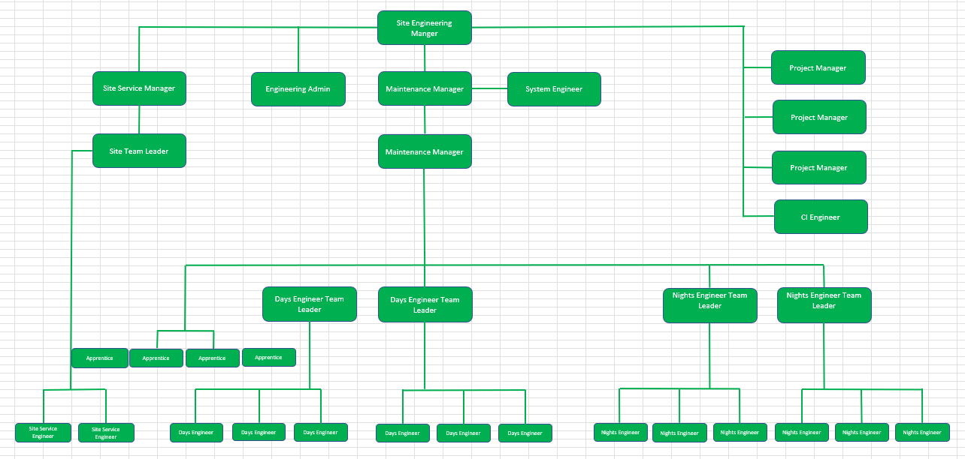

Accountabilities: ( 6 to 8 statements identifying the principal outputs required of the job in order to deliver its purpose).
- Reporting into and supporting Engineering Manager in attaining site objectives.
- Works with the engineering manager to collaboratively shape effective multifunctional business plans which mitigate risk and enhance efficiency, and can apply problem-solving skills (i.e., define problem, cause & effect, identify actions and achieve sustainable results through standardisation) in a complex production environment.
- Manage the life of building, plant and equipment assets through pro-active planned maintenance and strategic asset-care practice from purchase of new through to replacement or upgrade.
- Be accountable for contractor management, induction and permit to work, and ensuring that the adequate supervision of work performance and safe practice in place.
- Identify areas for improvement of Engineering practice to support overall efficiency and quality, and food safety. Deliver Continuous Improvement (CI) projects and Profit Improvement Plan (PIP) objectives through improvement teams, ensuring recommendations are implemented.
- Supports the build and development of a 5-year rolling capital plan to support the business to include costs, benefits and deliverables as well as key stakeholder needs.
- Can demonstrate a strong understanding of RCA tools, data analysis and critical thinking.
- Ensure continuous preparedness for internal and 3rd party audits and achievement of the highest grade against external standards, and to demonstrate this at audit.
- Host auditors and visitors to the site as required and demonstrates a thorough knowledge and understanding of the people, processes, and standards. Involve team members, where appropriate, to demonstrate team engagement and empower others.
- Facilitate effective communication between teams, other departments, and other sites.
- Address complex Employee Relations (ER) issues promptly and in line with Company values, People policies and processes, and best practice and coach line managers to do the same.
- Takes accountability for fair and ethical management of team in line with Company rules and Working Time Directive, ensuring line managers are taking a forward-thinking and supportive approach to the management of colleague leave, breaks, overtime and working hours.
- Be accountable for the people development and succession plans - monitor skills and capabilities against business requirements and put in place action plans which continually enhance business performance and support internal career progression. Ensure that line managers and colleagues fully utilise the development tools and resources.
- Deliver briefings and lead meetings, ensuring that information is effectively shared and cascaded, and solutions and actions are agreed. Offer clear direction on business and inter-departmental strategy.
- Drive improvement in energy and water efficiency, and effluent reduction through monitoring and targeting systems, multifunctional action plans and working with external parties. Also review and mitigate risks to supplies of utilities and put contingency plans in place.
- Demonstrate a high engineering profile on customer visits, audits, and initiatives
- Breadth of knowledge and understanding the business (factories etc) – focusing on site efficiency and health and safety objectives. Engaging others and working in the greater team to understand requirements of the total business therefore ensuring alignment of goals.
- Working with and engaging others to find opportunities to challenge and develop the performance of the department to improve the overall performance of the site.
- To actively promote a safety culture within the factory ensuring all Health & safety requirements are met.
- Ensure contractor controls and Legislative Compliance is in place.
- To order and maintain an appropriate level of replacement stocks.
- Manage the engineering team leaders and be responsible for their performance and development.
- To collate and deliver a weekly summary of KPI’s.
- Drive the continuous improvement of the culture, people, and practices within the business, ensuring a position of market leader rather than follower.
- To maintain & operate an effective PPM system. Reporting progress routinely.
- Deliver value initiatives to meet internal targets.
- Liaise with Operations Area Manager/Manufacturing Manager on strategic engineering matters.
- To ensure hygiene and technical standards are met and that employees adhere to hygiene regulations.

Competency Requirements: (Delete tick where competency doesn’t apply).
Values required from team: | Honesty, Passion, Determination, Loyalty.
Resilience | Never gives up. Relentless, proactive focus on reducing HS risks. Meet or exceeds targets without being asked.
Brilliant Execution | Use thinking skills to analyse, decide, prioritise and plan. Can balance short term requirements with long term objectives to achieve goals.
Communication and Influencing Skills | Able to influence people at all levels, internal and external, through listening and adjusting communication style to meet the needs of the audience.
Customer Focused | Understands the customer better than anyone else in the business. Always seeking to improve quality and service for our internal / external stakeholders.
Team Player | Works with colleagues to do what is best for the Company as a whole, ahead of divisional, department or personal goals.
Leadership | Puts the team first. Owns results of self and team. Inspires others to follow through involvement, coaching, setting direction and performance standards.
Knowledge / Skills / Qualifications: (What skills, qualifications and experience are necessary for FULL and EFFECTIVE performance?)

Relevant qualification in Mechanical/Electrical engineering
Documented experience in Site Service preference if BOAS trained.
Strong planning and organising ability
Ability to prioritise and work effectively under pressure. Highly developed communication skills (verbal, written, listening, influencing). Excellent coaching and training skills. Experience and proven ability in managing people and tasks.
Self-motivated and proactive approach to work.
Awareness of Health and Safety and other relevant legislation
Ability to communicate to all levels within the business

Decision Making
- To provide support and advice to engineering team and operational managers where appropriate.
- Exercise disciplinary to dismissal level.

