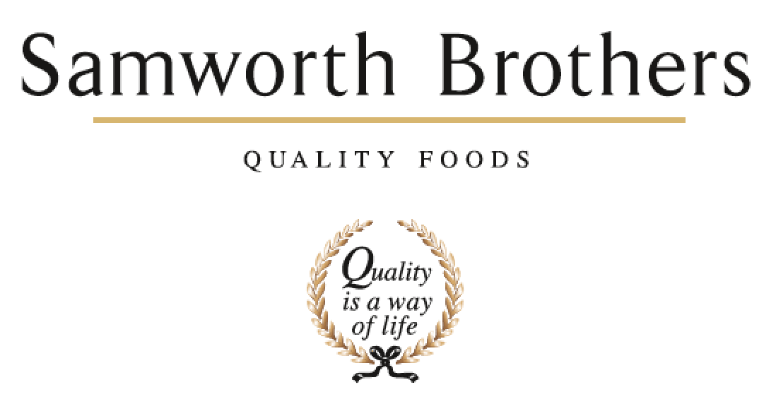

ROLE PROFILE
Job title | Development Chef | Date | August 2025
Business | Samworth Brothers Meals
Department | Commercial
Location | Kettleby/Samworths
ROLE SUMMARY
To manage and maintain the ongoing development of new and existing quality products in a fast-paced environment, through creative thinking, idea generation and the creation of new ideas and products that help inspire, generate and drive new or enhanced business in existing and emerging categories.

Passion for food and an ability to put this passion into products is essential with a drive to challenge and improve processes, product quality and where possible commerciality. Ongoing creative thinking to be presented clearly, accurately and persuasively to achieve the level of culinary excellence throughout the business.

Maintaining an awareness of market, consumer, restaurant trends and competitor activity through working with external teams and external fact finding.

The role requires regular customer interaction as well as with internal colleagues, to ensure customer briefs are met with commercial and technical requirements.

You will support and drive a one-team environment where people bring energy, excitement, learning and sharing together. Supporting the development of and championing one way of working so you, your peers and the wider teams you work alongside deliver at pace with discipline partnering with internal stakeholders to support business growth and profitability.

REPORTING STRUCTURE
Reports to | Snr Dev Chef
Direct & indirect reports | Kitchen Porters/Junior Chef
Key internal stakeholders | Snr PD Manager, Snr Development Technologist, Development Technologists, Snr Development Chef, Commercial & Category Teams, Costing Teams, Technical and Process  Ingredient Sourcing Specialist, Account Manager.
Key external stakeholders | Product Managers & Retail Chefs

KEY ACCOUNTABILITIES AND RESPONSIBILITIES
Responsible for product development and innovation in line with internal and customer briefs. To also have the ability to take a blue-sky approach to development opportunities. This also encompasses identifying global and local insights and food trends in conjunction with the internal insights, innovation, category and commercial teams working to support the business vision and customer strategy within a rolling 2-year horizon.

Develop products from ideation to approval in line with customer brief and brand values linked to the business strategy for growth. Ensuring commercially viable, creative and innovative products enable the business to keep ahead of the competition.

Liaise closely with the commercial, production, technical/process and other departments to ensure consistency and feasibility with the development of new products, and improvement of existing products. Ensure these are safe and take account of the capability and capacity available within the production areas.

Undertake effective liaison with external, internal customers/contacts, to support product Ideation/innovation and development activities whilst maintaining the necessary confidentiality requirements.

Ensure all aspects of the development process are carried out within the given budget expectation, looking for cost savings/improvements wherever possible.

Manage direct report colleagues where applicable and own workload, in a motivational and organised way to ensure smooth running of the development kitchen and PD workstream.

Liaise with ingredient sourcing for raw materials which add value to the product whilst maintaining the necessary margins and keep abreast of future innovations and opportunities

Be responsible for communicating accurate recipes and production methods, with QCCP for product launches and recipe changes. Support the development technologists to ensure that all relevant product information is provided on time and in full for internal and external meetings/requests in line with the development process.

Build and sustain knowledge of current products and processes for all Samworth Meals sites involved in development for the customer, challenge to improve where necessary.

Organise and prepare food samples, to include ordering of materials, costings, practical application and dispatch of product, assisting the team with the other projects where necessary.

Own and drive understanding of (and through aligned training) a strong commercial and factory process understanding to support the development of right first time products.

Work to set timescales and deadlines as outlined in a critical path via your manager..

Ensure excellent Hygiene and Safety standards are always maintained in the PD kitchen and during external customer visits

Provide hospitality / restaurant quality ideas and service for senior visitors or meetings/events.
As a customer-facing role the job holder is expected, at times to lead/support the insight, category, and commercial account managers when presenting idea/food opportunities and follow up meetings with the support of their manager and senior technologists (presentations and customer visits)
Drive and advocate cross functional working with all site based departments to ensure alignment through the development and stage & gate process.

Lead by example: Embody the desired culture and behaviours consistently demonstrating the values you want to
see in the team promoting open communication and collaboration by encouraging team members to share ideas, feedback, and concerns openly.

Recognise and celebrate achievements acknowledging both individual and team successes to boost morale and motivation.
Invest time in learning and team building - Providing opportunities for growth and development, such as training and mentorship, helping team members feel valued and invested in.

QUALIFICATIONS, EXPERIENCE, TECHNICAL SKILLS / KNOWLEDGE
- Minimum of 5 years’ experience as a chef, working within a quality restaurant/hotel environment, with at least 2 years manufacturing experience within a chilled food environment desirable
- Be able to demonstrate natural flair and passion for food and knowledge of a variety of cuisines.
- Be able to demonstrate practical cooking demonstrations to a high level.
- Demonstrate a natural ability to be creative and innovative in terms of recipes, marketing ideas and packaging solutions.
- Be able to present new products and improvements of existing products.
- Computer literate with a working knowledge of Microsoft Excel, PowerPoint and Word.
- Full Driving Licence required
- Proactive team player, able to perform under pressure and within tight timeframes
- Have a flexible approach to work and working hours, in order to meet the needs of the business.
CORE COMPETENCIES, ATTRIBUTES & BEHAVIOURS FOR SUCCESS
Competency | Descriptors
Values People | Demonstrates the belief that people are our most important asset and central to the success of the organisation. Everybody should be treated with dignity and respect at all times.
Customer Focus | Demonstrates the understanding that the satisfaction of our internal and external customers is the foundation of our success
Collaborative Team Working | The willingness to act as part of a team and work towards achieving shared objectives through adopting best practice
Flexibility & Adaptability | The ability to change and adapt own behaviour or work procedures when there is a change in the work environment, for example as a result of changing customer needs.
Initiative & taking ownership | Steps up to take on personal responsibility and accountability for tasks and actions
Drive for Excellence | Knows the most effective and efficient processes for getting things done, with a focus on continuous improvement.
Resource Management | Effectively manages resources and cost drivers to achieve sustainable productivity and profitability.
Technical Expertise | Has the skills, knowledge and experience required to excel in own area of specialism and the willingness to further grow and develop.
Self-Management | Uses a combination of feedback and reflection to gain insight into personal strengths and weaknesses, so that own time, priorities and resources can be managed to achieve goals.

