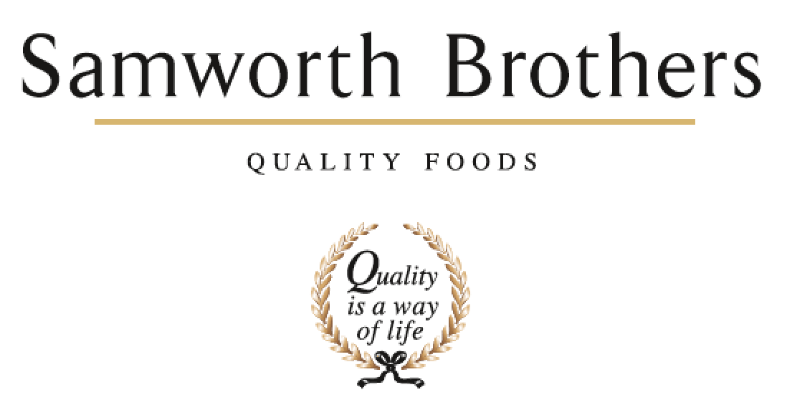

ROLE PROFILE
Job title | Innovation Technologist | Date | August 2025
Business | Samworth Brothers Meals
Department | Commercial
Location | Kettleby/Saladworks
ROLE SUMMARY
Support the Senior Innovation Technologist in the delivery of projects from initial concept idea to handover.
The purpose of this role is to ensure the PD function develops and delivers commercially viable products in line with our growth strategy.

Along with supporting the development of new concepts you will get involved with refreshing and optimising existing products following a development gate process.

You will work cross functionally in partnership with the Commercial, Category, Sourcing and Procurement functions, Production and Technical/Process teams in the development of new products from concept through to factory handover.

You will support and drive a one-team environment where people bring energy, excitement, learning and sharing together. Supporting the development of and championing one way of working so you, your peers and the wider teams you work alongside deliver at pace with discipline partnering with internal stakeholders to support business growth and profitability.

REPORTING STRUCTURE
Reports to | Senior Innovation Development Technologist
Direct & indirect reports
Key internal stakeholders | NPD Managers, Senior Chef, Development Chef, Junior Chef, Commercial & Category Teams, Costing Teams, Technical and Process, NPD Sourcing Specialists & Procurement
Key external stakeholders | TBC

KEY ACCOUNTABILITIES AND RESPONSIBILITIES
Assist the Senior Innovation Technologist in the daily project management of strategic and customer led projects.
Ensure deadlines are met in line with the launch process and critical paths, supporting the company objectives on cost.
Ensure product files are maintained through the launch process.
Ensure all aspects of the development process you are responsible for are carried out within the given budget expectation, looking for cost savings/improvements wherever possible.
Use Point 74 to create accurate recipes and nutritional summaries.
Briefing new raw materials and packaging to the sourcing log.
Ensure recipes are sent for costing in a timely manner and returned in line with Customer meetings/presentations.
Preparation of accurate paperwork for feasibilities/handovers and all customer meetings.
Arranging competitor samples availability for internal and customer meetings.
Amendment of paperwork through internal and external submissions and assurance of accuracy and compatibility with recipe versions.
Ensure recipe changes still meet customer brand values for each category.
Ensure recipe changes still meet QUID targets.
Accountable for the accurate and timely availability of submission paperwork.
Liaise with Ingredient Sourcing Specialist and Packaging Executive to ensure all raw materials and packaging are available for product development and submissions.
Build and sustain knowledge of current products and processes for all Samworth Meals sites involved in development for the customer, challenge to improve where necessary.

Work to set timescales and deadlines as outlined in a critical path via your manager..

Ensure excellent Hygiene and Safety standards are always maintained in the PD kitchen and during external customer visits

Working cross functionally with Technical, Process and operations to ensure alignment through the stage & gate process.
Responsible for courier arrangement for delivery of samples to meetings/photography.
Drive and advocate cross functional working with all site based departments to ensure alignment through the development and stage & gate process.

Lead by example: Embody the desired culture and behaviours consistently demonstrating the values you want to see in the team promoting open communication and collaboration by encouraging team members to share ideas, feedback, and concerns openly.

Recognise and celebrate achievements acknowledging both individual and team successes to boost morale and motivation. Invest time in learning and team building - Providing opportunities for growth and development, such as training and mentorship, helping team members feel valued and invested in.

QUALIFICATIONS, EXPERIENCE, TECHNICAL SKILLS / KNOWLEDGE
Min 1 years' experience in food manufacturing environment is desirable.
BSc or equivalent in a Food related discipline.
Project Management experience.
Competent with NPD software packages.
Strong organisational, and project management skills to assist with critical path deadlines and project priorities.
Knowledge of food production.
Can effectively time manage prioritise work.
Hardworking and accurate with an eye for detail.
Ability to problem solve
CORE COMPETENCIES, ATTRIBUTES & BEHAVIOURS FOR SUCCESS
Competency | Descriptors
Values People | Demonstrates the belief that people are our most important asset and central to the success of the organisation. Everybody should be treated with dignity and respect at all times.
Customer Focus | Demonstrates the understanding that the satisfaction of our internal and external customers is the foundation of our success
Collaborative Team Working | The willingness to act as part of a team and work towards achieving shared objectives through adopting best practice in line with PQP and Federalism.
Flexibility & Adaptability | The ability to change and adapt own behaviour or work procedures when there is a change in the work environment, for example as a result of changing customer needs.
Initiative & taking ownership | Steps up to take on personal responsibility and accountability for tasks and actions in line with PQP and Federalism.
Drive for Excellence | Knows the most effective and efficient processes for getting things done, with a focus on continuous improvement.
Resource Management | Effectively manages resources and cost drivers to achieve sustainable productivity and profitability.
Technical Expertise | Has the skills, knowledge and experience required to excel in own area of specialism and the willingness to further grow and develop.
Self-Management | Uses a combination of feedback and reflection to gain insight into personal strengths and weaknesses, so that own time, priorities and resources can be managed to achieve goals.

