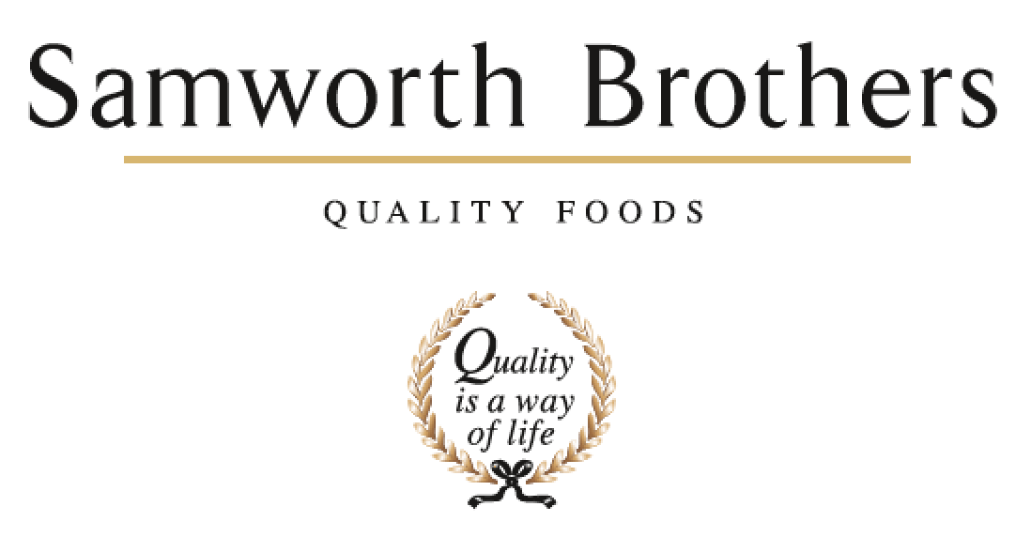

ROLE PROFILE
Job title | Production Operative Grade A | Date | July 22
Department | Operations
Location | Trafford Park
ROLE SUMMARY
Summarise in one or two sentences the highlights of the job in terms of its purpose and overall responsibility.
To ensure the timely production of bakery goods to agreed standards, safely and effectively. To be multi skilled on all tasks in your area.
REPORTING STRUCTURE
Reports to | Shift Manager

KEY ACCOUNTABILITIES AND RESPONSIBILITIES
- Ensure the timely and efficient production of bakery goods to agreed targets and specifications.
- Should ensure all paperwork is completed in a timely manner and to the required standard.
- Should complete all work to the highest quality standards at all times, adhering to all quality systems and legal regulations in place.
- Should work on own initiative and in conjunction with the Section Leader to prioritise tasks.
- Should operate in a safe and correct manner at all times. Should also ensure the area of work is a safe place to work within at all times for yourself and others. PPE will be provided and it is your responsibility to ensure that you wear the correct PPE.
- Should adopt and enforce good housekeeping and hygiene practices at all times.
- Should possess the correct competencies, at the correct level relevant to the job function as detailed in the competency matrix i.e. Wrapping, Divider, De-Panner etc.
- Should proactively and continually strive to improve the production process and working environment.
- Should be professional at all times and possess the values and behaviours adopted by the company.
- Should proactively work within multi-disciplined teams in order to achieve agreed objectives.
- Should have a good understanding of the production processes and business objectives.

QUALIFICATIONS, EXPERIENCE, TECHNICAL SKILLS / KNOWLEDGE
Essential Skills / Experience:
- Experience of working in a food manufacturing environment.
- Able to follow written and verbal instructions
- Excellent attention to detail
- Positive, flexible attitude

